

Princess Sumaya University for Technology

King Hussein School for Computing Sciences

**BridgeLocal  
Empowering Jordanian Manufacturers**

**Prepared By:**

Rafeeq Al-Shareef 20190179  
Mohammad Abuayyash 20200560

Hussam Jabban 20200920

Hamzeh Nsirat 20190725

**Supervised By:**

Dr. Raghda Hraiz

Project Submitted in partial fulfillment for the degree of Bachelor of Science in Computer Science

Second Semester -2024

**Declaration of Originality**

This document has been written entirely by the undersigned team members of the project. The source of every quoted text is clearly cited and there is no ambiguity in where the quoted text begins and ends. The source of any illustration, image or table that is not the work of the team members is also clearly cited. We are aware that using non-original text or material or paraphrasing or modifying it without proper citation is a violation of the university’s regulations and is subject to legal actions.

Names and Signatures of team members:

**Rafeeq Al-Shareef  
Mohammad Abuayyash**

**Hussam Jabban**

**Hamzeh Nsirat**

**Acknowledgments**

This project holds great personal significance to us, inspiring us to help local producers in Jordan overcome market entry barriers. Witnessing the challenges they face in gaining traction motivated us to take this step.

We would like to express our deepest gratitude to Dr. Raghda Hraiz for her invaluable guidance and support throughout this project. Her expertise has been instrumental in shaping BridgeLocal.

Lastly, we extend our heartfelt appreciation to our peers and faculty members at Princess Sumaya University for their encouragement and assistance. Alse we would like to extend our gratitude to our families for the continuous support throughout the duration of this project. Their encouragement has been a constant source of motivation. This project would not have been possible without the collaborative efforts and insightful feedback from all involved.

Summary

Small-scale local producers in Jordan are unable to compete in the market and achieve

recognition because larger manufacturers frequently overrun them. This indicates that there is an

urgent need for a system that can successfully link these regional producers with retailers

guaranteeing an environment that is fair and competitive and showcases high quality regional

goods.

By enabling local manufacturers in Jordan the Bridge Local online application aims at bridging

this gap. It seeks to give businesses a strong platform on which to present their goods, interact

with merchants directly and thereby increase their market share.

Through standardizing the sales process of products to retailers this platform hopes to endorse local businesses while providing retailers with a wide selection of goods. By using a user-oriented design approach the project facilitates an intuitive process for retailers as well as manufacturers. Our methodology which included carrying out holistic market research tailored to the domestic context, was followed by creating a prototype that is safe, scalable and easy to use.

This includes implementing features like data analytics, user-specific dashboards, a process for validating products and payment methods. The project's strategy focuses on addressing issues with user adoption, data security and the advancement of sustainable business practices.

These issues will be dealt with through demo training, intuitive User Interface design, encryption, regular audits and compliance with industry standards.

In Conclusion BridgeLocal is a cutting-edge solution designed specifically for the Jordanian

market. It has the potential to greatly increase the visibility of local manufacturers in which it simplifies the procurement process for retailers and cultivate an interconnected business

community. In addition, BridgeLocal aims at supporting local businesses in Jordan by addressing essential market demands and creating a sustainable local economy.

**List of Abbreviations**

List the abbreviations you have used in your project if there are any and what they stand for.

**UML**: Unified Modeling Language.

**JSP**: Java Server Pages.

**DLL**: Dynamic Link Library.

**CMS**: Content Management System.

**ERD**: Entity Relationship Diagram.

**OO**: Object Oriented

Table of Contents

Chapter 1 10

Introduction 10

1.1 Overview 10

1.2 Problem Statement 10

1.3 Related Work 11

1.4 Document Outline 13

Chapter 2 14

Project Plan 14

2.1 Project Deliverables 14

2.2 Project Tasks 14

2.3 Roles and Responsibilities 17

2.4 Risk Assessment 18

2.5 Cost Estimation 21

2.6 Project Management Tools 22

Chapter 3 23

Requirements Specification 23

3.1 Stakeholders 23

3.2 Platform Requirements 24

3.3 Functional Requirements 25

3.3.1 Common Functional Requirements 25

3.3.2 System Administrator Functional Requirements 26

3.3.3 Retailer Functional Requirements 27

3.3.4 Supplier Functional Requirements 29

3.4 Non-Functional Requirements 31

Chapter 4 32

System Design 32

4.1 Logical Model Design 32

4.1.1 Use Case Diagram 33

4.1.2 Class Diagram 39

4.1.3 Object Diagram 43

4.1.4 Package Diagram 44

4.1.5 Component Diagram 46

4.1.6 Deployment Diagram 47

4.1.7 Activity Diagram 48

4.1.8 Sequence Diagram 51

4.1.9 State Transition Diagram 53

4.2 Physical Model Design 54

4.2.1 Database Design 54

4.2.1.1 Database Entity Relationship Diagram 54

4.2.1.2 Database Schema 57

4.2.2 User Interface Design 58

References 84

Appendix 85

Local Supplier Results: 85

General Audience Results: 87

Table of Tables

Table 1.1 Applications Comparison 12

Table 1.2 Documentation Outline 13

Table 2.1 Project Tasks 15

Table 2.2 Roles & Responsibilities 17

Table 2.3 Risk Assessment 18

Table 2.4 Cost Estimation 21

Table 2.5 Project Management Tools 22

Table 3.1 Stakeholders 23

Table 3.2 Client Requirements 24

Table 3.3 Server Requirements 24

Table 3.4 Common Functional Requirements 25

Table 3.5 System Administrator Functional Requirements 26

Table 3.6 Retailer Functional Requirements 27

Table 3.7 Supplier Functional Requirements 29

Table 3.8 Non-Functional Requirements 31

Table 4.1 Typical Course of Action - Forget Password 33

Table 4.2 Typical Course of Action – View Complaints 35

Table 4.3 Typical Course of Action – Request Quotation 36

Table 4.4 Typical Course of Action – Send Quotation 38

Table of Figures

Figure 2.1 Gantt Chart 16

Figure 2.2 Pert Chart 17

Figure 2.3 SWOT Grid 20

Figure 4.1 Use Case Diagram 1 33

Figure 4.2 Use Case Diagram 2 34

Figure 4.3 Use Case Diagram 3 36

Figure 4.4 Use Case Diagram 4 37

Figure 4.6 Class Diagram - Part1 41

Figure 4.7 Class Diagram - Part2 42

Figure 4.8 Class Diagram - Part3 42

Figure 4.9 Object Diagram 1 43

Figure 4.10 Object Diagram 2 43

Figure 4.11 Package Diagram 1 44

Figure 4.12 Package Diagram 2 45

Figure 4.13 Component Diagram 46

Figure 4.14 Deployment Diagram 47

Figure 4.15 Activity Diagram 1 48

Figure 4.16 Activity Diagram 2 49

Figure 4.17 Activity Diagram 3 50

Figure 4.18 Sequence Diagram 1 51

Figure 4.19 Sequence Diagram 2 52

Figure 4.20 State Diagram 1 53

Figure 4.21 State Diagram2 53

Figure 4.22 Entity Relationship Diagram 55

Figure 4.23 Entity Relationship Diagram - Part1 56

Figure 4.24 Entity Relationship Diagram - Part2 56

Figure 4.25 Entity Relationship Diagram - Part3 57

Figure 4.26 Relational Schema 57

Figure 4.27 BridgeLocal - Landing Page 58

Figure 4.28 BridgeLocal – Log in Page 59

Figure 4.29 BridgeLocal – Retailer Sign up Page (1) 60

Figure 4.30 BridgeLocal – Retailer Sign up Page (2) 61

Figure 4.31 BridgeLocal – Retailer Sign up Page (3) 62

Figure 4.32 BridgeLocal – Supplier Sign up Page (1) 63

Figure 4.33 BridgeLocal – Supplier Sign up Page (2) 64

Figure 4.34 BridgeLocal – Supplier Sign up Page (3) 65

Figure 4.35 BridgeLocal – Administrator Sign up Page 66

Figure 4.36 BridgeLocal – Administrator User Management Page (1) 67

Figure 4.37 BridgeLocal – Administrator User Management Page (2) 68

Figure 4.38 BridgeLocal – Complaints Management Page 69

Figure 4.39 BridgeLocal – Administrator Dashboard Page 70

Figure 4.40 BridgeLocal – Marketplace Retailer View (1) 71

Figure 4.41 BridgeLocal – Marketplace Retailer View (2) 72

Figure 4.42 BridgeLocal – Retailer Related Page (1) 73

Figure 4.43 BridgeLocal – Retailer Related Page (2) 74

Figure 4.44 BridgeLocal – Retailer Related Page (3) 75

Figure 4.45 BridgeLocal – Retailer Related Page (4) 76

Figure 4.46 BridgeLocal – Retailer Related Page (5) 77

Figure 4.47 BridgeLocal – Supplier Related Page (1) 78

Figure 4.48 BridgeLocal – Supplier Related Page (2) 79

Figure 4.49 BridgeLocal – Supplier Related Page (3) 80

Figure 4.50 BridgeLocal – Supplier Related Page (4) 81

Figure 4.51 BridgeLocal – Supplier Related Page (5) 82

Figure 4.52 BridgeLocal – Supplier Related Page (6) 83

Figure A.1 Local Supplier Results 85

Figure A.2 Local Supplier Results 85

Figure A.3 Local Supplier Results 86

Figure A.4 Local Supplier Results 86

Figure A.5 Local Supplier Results 86

Figure A.6 General Audience Results 87

Figure A.7 General Audience Results 87

# Chapter 1

## Introduction

### **1.1 Overview**

BridgeLocal is a platform created to endorse the Jordanian economy by increasing local manufacturers' visibility and access to markets. The goal of BridgeLocal is to shorten the gap between small-medium scale producers and retailers by providing a simple, safe and effective platform for local product discovery and sales. An analytics driven interface for retailers to track purchase history and product profitability in which there is a comprehensive dashboard for manufacturers to monitor product performance, receive feedback and advanced features like product validation and secure payment processing are the main use cases of BridgeLocal.

### **1.2 Problem Statement**

The main aim of BridgeLocal is to resolve is the considerable barrier that Jordanian local manufacturers experience when trying to enter the market and gain traction. Small scale producers frequently face difficulties competing with larger enterprises because they have restricted access to retail networks and have trouble reaching potential customers. Furthermore, the current markets and platforms are unable to fully address the particular requirements of local Jordanian producers, creating a void in the market where premium and locally produced goods are marginalized and underrepresented. This situation not only limits local businesses' potential for growth but also denies customers and retailers access to a wide variety of high quality locally produced goods.

Bridge Local's primary goal is to develop a web application that functions as a marketplace and a tool for business-to-business networking, improving product visibility, guaranteeing product authenticity, and expediting the purchase process. In addition to improving the financial prospects of local producers this approach aims to strengthen and expand the local economy by providing a wide range of superior and local products to the retail sector.

### **1.3 Related Work**

However, some applications offer similar services and features that could potentially be present in our system:

1. Faire:

Faire is a marketplace connecting retailers with independent brands. Available in  
countries like the United States, Canada and the United Kingdom. Suitable for retailers  
looking for a filtered selection of products from established independent brands. It offers a  
wide variety of products like Home Decor, food / beverage, Clothing and more.  
Benefits for retailers are flexible payment terms, free returns on opening orders, curated  
product recommendations and a user-friendly platform. Some distinctive characteristics include:

* Delicate Selection: Faire validate brands, ensuring a high quality selection for retailers.
* Wholesale purchase: Retailers can purchase products in bulk at wholesale prices.
* Flexible Payment: Offers flexible payment options for retailers.
* Free Returns on Opening Orders: Reduces risk for retailers trying new products.

2. Jungleworks Yelo:

Jungleworks Yelo is a web-based platform designed for local businesses to establish an online

presence. Located in the USA Yelo equips local businesses with the tools they need to create an

online store, manage inventory and engage customers. Features include digital storefront creation,

inventory management tools, and customer engagement tools (may vary depending on the plan).

Yelo offers a free trial along with paid plans. Among Jungleworks Yelo's key characteristics are:

* Local Business Focus: Tailored specifically for the needs of local businesses.
* Easy Online Store Creation: platform allows businesses to set up an
* online store.
* Integrated Gadgets: tools for managing inventory and engaging customers.
* Free Trial: Allows businesses to try the platform before committing to a paid plan

3. RangeMe (rangeme.com)

RangeMe is a web-based marketplace located in the USA connecting brands with retailers and distributors across various categories. A valuable tool for both brands and retailers. Brands can showcase their products and connect with potential buyers, while retailers can discover new and innovative products from a wide range of brands. RangeMe offers a freemium model with a free basic plan and paid options for additional features.Among the numerous distinctive elements of this application are:

* Broad Reach: Ideal for brands seeking to expand their reach and retailers looking for a diverse selection of products.
* Freemium Model: Caters to different needs with a free plan and paid options.
* Brand-Retailer Connection: Facilitates communication and product discovery between brands and retailers.
* Focus on Discovery: Helps brands get discovered by potential buyers and allows retailers to find unique products.

Table 1.1 Applications Comparison

|  |  |  |  |  |
| --- | --- | --- | --- | --- |
| *Features* | *BridgeLocal* | *Faire* | *Jungleworks (Yelo)* | *RangeMe* |
| *Jordan Based* | Yes | No | No | No |
| *Target Audience* | Local Manufacturers and Retailers | Retailers | Brands & Retailers | Local Business |
| *Focus* | Local Business Networking & Support | Wholesale Buying | Product Distribution | Online Store Creation |
| *Similarities* | User-friendly interface, connects businesses in e-commerce space | User-friendly interface, e-commerce focus | Connects businesses in e-commerce space | N/A |
| *Key Differences* | Promoting local businesses mainly | Focus on pre-vetted brands, wholesale buying | Focus on brand discovery, wider reach | For local businesses, online store creation |

In addition to the above: there exist other platforms that provide similar services such as GO Wholesale, MerchantCircle, Mable.

### **1.4 Document Outline**

The document provides a comprehensive and structured approach to the development and implementation of BridgeLocal, a platform aimed at empowering local manufacturers in Jordan by bridging the gap between them and retailers. Each chapter of the document carefully outlines different aspects of the project, ensuring a thorough understanding and effective execution. The following is the detailed outline of the document:

Table 1.2 Documentation Outline

|  |  |
| --- | --- |
| *Chapter Title* | *Description* |
| *Chapter 1: Introduction* | Includes a brief overview of the project and a summary of the problem the project is trying to solve. |
| *Chapter 2: Project Plan* | Includes a detailed explanation of the project plan, the role of each team member, cost estimation, and necessary tools. |
| *Chapter 3: Requirements Specification* | Includes a detailed description of the system functional and nonfunctional requirements as well as declaration of the stakeholders. |
| *Chapter 4: System Design* | Includes a detailed analysis of the system components, and low- and high-level designs of the system. |

# Chapter 2

## Project Plan

### **2.1 Project Deliverables**

**BridgeLocal** encompasses a comprehensive set of components crucial for its development, deployment, and effective use. These include the complete source code and detailed documentation covering all system aspects, as well as the database schema with initialization scripts. Additionally, high-fidelity user interface designs and strict security guidelines ensure the platform is scalable, secure, and user-friendly. Together, these deliverables form the backbone of the Bridge Local platform, facilitating a direct connection between local manufacturers and retailers, promoting local products, and fostering a sustainable market environment in Jordan.

### **2.2 Project Tasks**

Table 2.1 shows the tasks that will and have taken place during our project. The project starts with the analysis phase, where the main project idea and requirements were stated. The next tasks are in the design phase, where the logical model design and user interface prototyping are completed. After the design phase, we are expected to complete implementation at a later time, when the system will be fully functional and ready for the user. Every phase has been given an expected completion time.

Table 2.1 Project Tasks

|  |  |  |  |  |  |  |
| --- | --- | --- | --- | --- | --- | --- |
| ***Task ID*** | ***Task Name*** | ***Description*** | ***Dependencies*** | ***Start Date*** | ***Due Date*** | ***Completed*** |
| **Analysis** | | | | | | |
| *T1* | Brainstorming Ideas | Meeting with the project supervisor to discuss project ideas | - | 3/3/2024 | 7/3/2024 | 100% |
| *T2* | The general idea  and problem  statement | Planning and discussion of the  project with group individuals | T1 | 10/3/2024 | 12/3/2024 | 100% |
| *T3* | Requirements Gathering | Collecting information from local manufacturers about their needs for the application and the database. | T1 | 10/3/2024 | 14/3/2024 | 100% |
| *T4* | Scope Definition | Defining the features and  functionality that will be included in  the project as well as constraints and  Limitations | T3 | 17/3/2024 | 21/3/2024 | 100% |
| *T5* | Related Work | Researching similar applications and competitors | T4 | 24/3/2024 | 28/3/2024 | 100% |
| **Design** | | | | | | |
| *T6* | Documentation design | Involves designing the documentation for the application and the database, including manuals, specifications, and system diagrams | T1 | 17/3/2024 | 11/5/2024 | 100% |
| *T7* | User-Interface design | Designing our website’s interface | T5 | 14/4/2024 | 11/5/2024 | 100% |
| *T8* | Database design | Designing the database for the website | T5 | 14/4/2024 | 11/5/2024 | 100% |
| *T9* | Documentation Finalization | Finalizing and organizing the four chapters | T8 | 11/5/2024 | 19/5/2024 | 100% |
| *T10* | Presentation Preparation | Preparing for the project presentation | - | 19/5/2024 | 25/5/2024 | 100% |
| **Implementation** | | | | | | |
| *T11* | Coding and Development | Writing the code for the interface, database development | T7,T8,T9 | 6/10/2024 | 28/12/2024 | 0% |
| *T12* | Testing | Conducting rigorous testing of the developed system | T11 | 29/12/2024 | 11/1/2025 | 0% |

The figure below Figure 2.1 shows a Gantt chart of the project tasks, it provides a detailed outline of the duration each task took and a completion date estimation. Tasks in orange shows the set of tasks related to the Analysis phase of the SDLC, while the set in green shows the ones related to design.

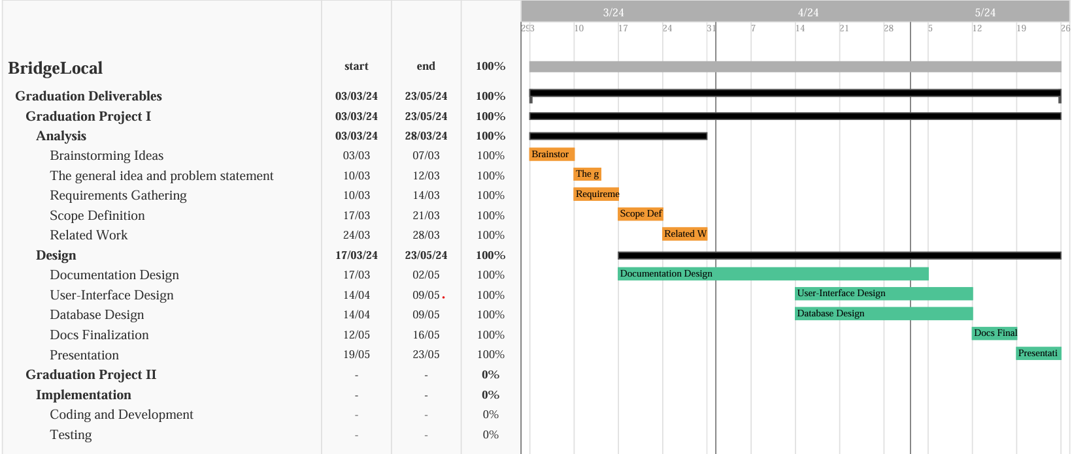

Figure 2.1 Gantt Chart

The figure below Figure 2.2 shows a PERT chart of the project tasks, it provides an overview of tasks interrelation and dependence.

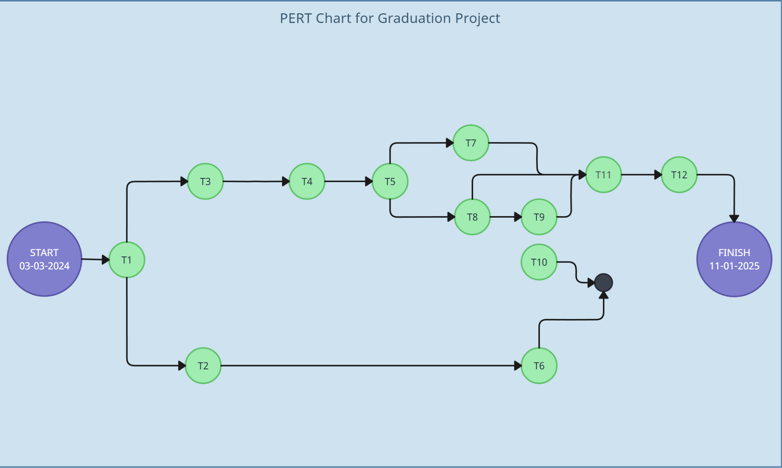

Figure 2.2 Pert Chart

### **2.3 Roles and Responsibilities**

*Table 2.2* shows the roles of each team member in the project and what tasks they will be responsible for.

Table 2.2 Roles & Responsibilities

|  |  |
| --- | --- |
| *Member Name* | *Responsibility* |
| *Mohammad Abuayyash* | Documentation, Database, and Back-end |
| *Hamzeh Nsirat* | Documentation, Database, and Back-end |
| *Rafeeq Al-Shareef* | Documentation, Database, and Front-end |
| *Hussam Jabban* | Documentation, Design, and Front-end |

### **2.4 Risk Assessment**

*Table 2.3* shows the possible obstacles and issues we might come across, We also provided a risk response, which shows what can be done to avoid these potential risks.

Table 2.3 Risk Assessment

|  |  |  |  |  |  |
| --- | --- | --- | --- | --- | --- |
| *Risk ID* | *Task ID* | *Task Name* | *Risk Description* | *Probability* | *Risk Response* |
| *R1* | T1 & T2 | Brainstorming ideas and the idea and problem statement | Conflict about the project specifications and misunderstanding of the project goals | Low | Making sure that everyone has a comprehensive understanding of the project requirements and ensure that everyone is on the same page moving forward |
| *R2* | T3 | Requirement  Gathering | Inadequate understanding of user requirements leading to incomplete or incorrect feature implementation | Medium | Conduct thorough interviews and surveys with local manufacturers to gather requirements. Prioritize based on impact and feasibility. |
| *R3* | T4 | Scope Definition | Unclear project scope resulting in scope creep or project delays | Medium | Collaborate closely with stakeholders to define clear project scope and objectives. Document scope boundaries and constraints. |
| *R4* | T5 | Related Work | Not finding applications related to our project | Low | Conducting an extensive search of applications |
| *R5* | T6 | Documentation design | The documentation may be incomplete or inaccurate | Low | Establishing clear documentation guidelines and ensuring the documentation is organized and accessible |
| *R6* | T7 | User-Interface design | Not providing the user with an adequate user-interface results in poor user experience | High | Ensuring the user is involved in the UI design process and conducting usability testing |
| *R7* | T8 | Database design | Inefficient database design may result in poor query performance, slow data retrieval, or inefficient storage structures | High | Prioritizing a thorough analysis of data requirements and implementing an optimized database structure |
| *R8* | T9 | Documentation Finalization | Not completing the documentation on due date | Low | Making sure every chapter has a designated time period and sticking to the project plan |
| *R9* | T10 | Presentation Preparation | Unclear communication of project purpose and main goal | Low | Ensuring that everyone in the team is well prepared and understands the project’s problem statement in addition to conducting several rehearsing sessions |

The SWOT analysis provides a clear overview of the internal and external factors that impact the BridgeLocal project. The strengths highlight the platform's ability to support the local economy, foster sustainability, and provide advanced analytics and product validation tailored for the Jordanian market. Weaknesses such as dependency on user adoption, initial market competition, and the required skillset for development and maintenance are identified. Opportunities include potential zexpansion to other markets, integration with local payment gateways, and community-building features. However, the project must also navigate threats such as market dominance by large manufacturers, cybersecurity risks, and rapid technological change.

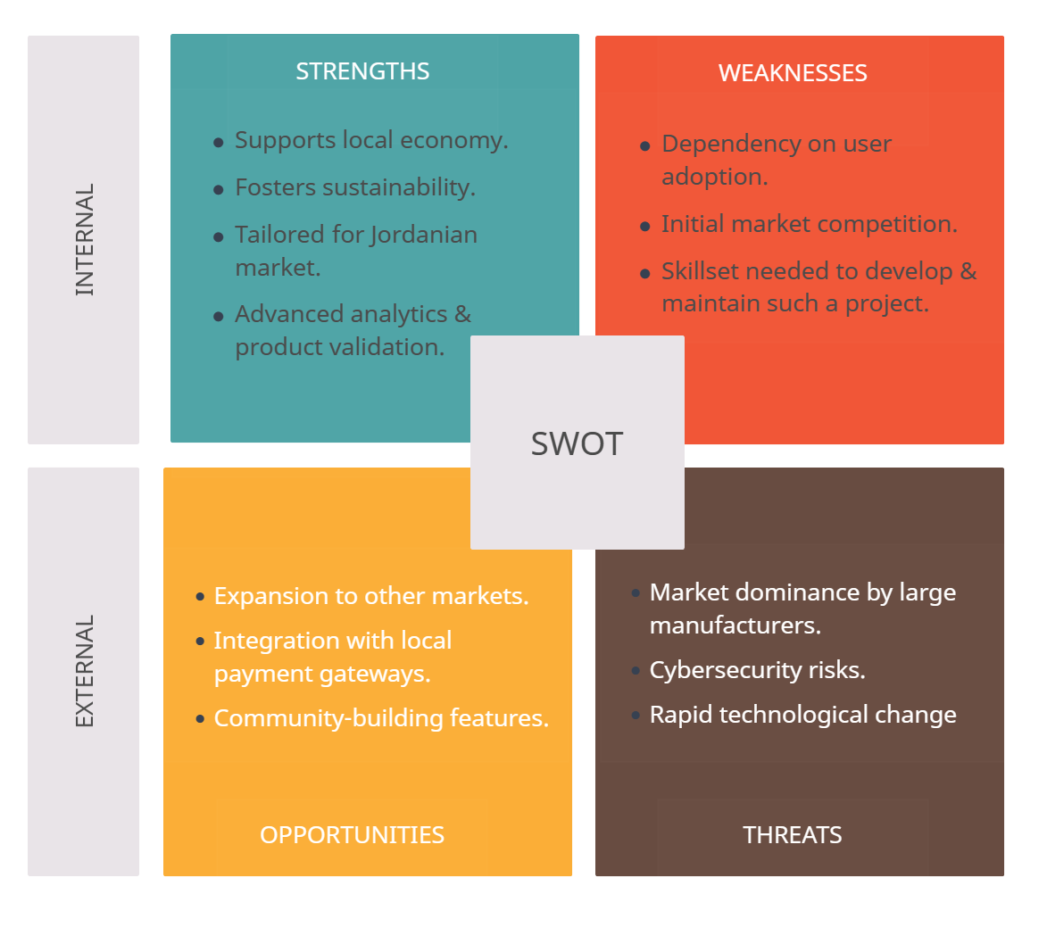

Figure 2.3 SWOT Grid

### **2.5 Cost Estimation**

*Table 2.4* describes the services needed for this project in addition to the cost estimation of each service and a brief description on how these services are used.

Table 2.4 Cost Estimation

|  |  |  |  |
| --- | --- | --- | --- |
| *Service* | *Cost Estimate* | *Description* | *Actual Cost* |
| *Servers* | $2500 ONE TIME | Servers play a crucial role in the infrastructure of any web-based application. They host the application, manage requests from clients and store data. | $0 |
| *Development Tools and software Licenses* | $150 per user/year | Software licenses for development tools, integrated development environments (IntelliJ IDEA), and other necessary utilities | $0 |
| *Domain Registration* | $10-$20 per year | Provides a recognizable and professional web address for users to access BridgeLocal | - |
| *SSL Certificate* | $200 per year | An SSL certificate encrypts data transferred between users and the website, which is crucial for security | Free Access |
| *Cloud Services and Hosting* | $100 per month | Cloud Hosting: is essential for deploying and scaling the application  Cloud Storage: For storing user data, product images, and other content. | - |

### **2.6 Project Management Tools**

*Table 2.5* shows the tools that will be used in the implementation of this project.

Table 2.5 Project Management Tools

|  |  |
| --- | --- |
| *Tool* | *Description* |
| *Google Docs* | Documentation |
| *Google drive* | Sharing folders between team members |
| *Creately* | PERT chart |
| *TeamGantt* | Gantt Chart |
| *Lucidchart* | UML Design |
| *Figma* | Interface Design |
| *Visual Studio Code* | Front-End Development |
| *IntelliJ IDEA* | Back-End Development |
| *PostgreSQL* | Database Interfacing and Administration |
| *AWS Services* | Cloud Services for Storage and Computing |

# Chapter 3

## Requirements Specification

### **3.1 Stakeholders**

*Table 3.1* defines the stakeholders of the system, their importance, and how they benefit from our platform.

Table 3.1 Stakeholders

|  |  |  |
| --- | --- | --- |
| *ID* | *Stakeholder* | *Description* |
| *S1* | Local Suppliers | Local suppliers are individuals or businesses that produce goods locally within Jordan. They are the primary users of the BridgeLocal platform, utilizing it to showcase and sell their products to a wider audience. |
| *S2* | Retailers | Retailers are businesses or individuals who sell products to end consumers. They utilize BridgeLocal to discover and purchase locally produced goods to stock in their stores or sell online. |
| *S3* | System Administrator | The system administrator is responsible for the overall management of the system, this is an essential role to ensure that the system stays reliable and secure. |
| *S4* | Guest User | Guest Users can view platform services. |

### **3.2 Platform Requirements**

*Table 3.2, Table 3.3* describe the client requirements and server requirements respectively, in addition to their importance.

Table 3.2 Client Requirements

|  |  |  |
| --- | --- | --- |
| *Requirement* | *Requirement Name* | *Importance* |
| *CR1* | PC or Laptop or Mobile | Required |
| *CR2* | Connection to Internet | Required |
| *CR3* | Connection to Server | Required |

Table 3.3 Server Requirements

|  |  |  |
| --- | --- | --- |
| *Requirement* | *Requirement Name* | *Importance* |
| *SR1* | Access to Database | Required |
| *SR2* | Connection to Internet | Required |

### **3.3 Functional Requirements**

#### **3.3.1 Common Functional Requirements**

Table 3.4 describes the common functional requirements of the system and outlines the features that all users can have.

Table 3.4 Common Functional Requirements

|  |  |  |
| --- | --- | --- |
| *ID* | *Requirement* | *Description* |
| *CFR1* | User Login | Allows users to get into their specified dashboard based on the information provided. |
| *CFR2* | User Sign up | Allows new users to join by providing their personal information. |
| *CFR3* | Dashboard | Each type of user has a specified dashboard that they are redirected to after checking their login information. |
| *CFR4* | Forget Password | Allows users to easily change their passwords and confirmation to ensure security measures are upheld. |
| *CFR5* | User Logout | The users have the option to logout of their accounts anytime they want. |
| *CFR6* | Navigation Menu | The landing page of the website provides a navigation menu that educates the user about our website and what exactly it does, it helps them learn more about the services provided. |
| *CFR7* | Access Control | Users should have appropriate access rights based on their roles and permissions. |
| *CFR8* | View Platform Services | Users can view detailed information on all available services, search, filter by category, sort, and read reviews to easily find and compare services. |

#### **3.3.2 System Administrator Functional Requirements**

*Table 3.5* describes the functional requirements of the system from the system administrator’s perspective. As the main mediator of the system, they can do all the operations

Table 3.5 System Administrator Functional Requirements

|  |  |  |
| --- | --- | --- |
| *ID* | *Requirement* | *Description* |
| *SAFR1* | View Users | System administrators should have the ability to view users such as retailers and local suppliers. |
| *SAFR2* | View Applications | System administrators should be able to review applications from suppliers and retailers upon signing up. |
| *SAFR3* | Apply Penalties | System administrators should have the authority to apply penalties upon violation of order fulfillment, order payment, and other relevant policies. |
| *SAFR4* | Add Users | System administrators should be able to add users to the system. |
| *SAFR5* | Edit Users | System administrators should be able to edit users to the system. |
| *SAFR6* | Delete Users | System administrators should be able to delete users to the system. |
| *SAFR7* | Approve Applications | System administrators should be able to approve applications sent by suppliers and retailers. |
| *SAFR8* | Reject Applications | System administrators should be able to reject applications sent by suppliers and retailers. |
| *SAFR9* | View Complaints | System administrators should be able to view complaints sent by suppliers to retailers and vice versa. |

#### **3.3.3 Retailer Functional Requirements**

*Table 3.6* describes the functional requirements of the system from the retailer’s perspective.

Table 3.6 Retailer Functional Requirements

|  |  |  |
| --- | --- | --- |
| *ID* | *Requirement* | *Description* |
| *RFR1* | View Account Info | Retailers should be able to view their account information easily. |
| *RFR2* | Update Account Info | Retailers should be able to update their account information easily. |
| *RFR3* | View Requested Quotations | Retailers should be able to view quotations that have been sent to the supplier. |
| *RFR4* | View Dashboard Content | Retailers should have access to a customized dashboard featuring data analytics and visualization tools. |
| *RFR5* | Export Dashboard Content | Retailers should be able to export dashboard content as a PDF |
| *RFR6* | Search Marketplace and Filter by Category. | Retailers should be able to search the marketplace for products and filter results based on categories, and other relevant metrics. |
| *RFR7* | View Product | Retailers should be able to view supplier products |
| *RFR8* | Save Favorite Listings | Retailers should have the ability to save favorite listings from search results for later reference. |
| *RFR9* | View Past Purchases Performance | Retailers should be able to view past purchases' performance based on factors such as profits and quality ratings. |
| *RFR10* | Request Quotation | Retailers should be able to request quotations from local suppliers for desired products. |
| *RFR11* | View Selected Quotation | Retailer should be able to view a selected quotation from the quotation list. |
| *RFR12* | Accept The Supplier’s Placed Quotation | Retailer should be able to accept the quotation that is sent by the supplier. |
| *RFR13* | Cancel Send Quotation | Retailers should have the option to cancel their quotation requests to suppliers. |
| *RFR14* | View Supplier’s Related Products | Retailers should be able to view other supplier’s products when they request the quotation. |
| *RFR15* | Add Supplier’s Related Products | Retailers should be able to add other supplier’s products to the requested the quotation. |
| *RFR16* | Cancel Order | Retailers should be able to cancel orders that been sent to suppliers. |
| *RFR17* | Add Feedback | Retailers should be able to give feedback for the supplier based on their products. |
| *RFR18* | Escalate Order Fulfillment Failures | Retailers should be able to escalate order fulfillment failures to resolve issues promptly. |
| *RFR19* | Monitor Purchase Status | Retailers should be able to monitor the status of their purchases, including quotation responses, bid-order process, payment, delivery, and feedback. |

#### 

#### **3.3.4 Supplier Functional Requirements**

*Table 3.7* describes the functional requirements of the system from the supplier’s perspective.

Table 3.7 Supplier Functional Requirements

|  |  |  |
| --- | --- | --- |
| *ID* | *Requirement* | *Description* |
| *SFR1* | View Account Info | Suppliers should be able to view their account information easily. |
| *SFR2* | Update Account Info | Suppliers should be able to update their account information easily. |
| *SFR3* | View Product | Suppliers should be able to view their products. |
| *SFR4* | Upload Products | Suppliers should be able to upload product listings on the platform. |
| *SFR5* | Edit Products | Suppliers should be able to edit product listings on the platform. |
| *SFR6* | Search Products | Suppliers should be able to search for their products on their lists. |
| *SFR7* | Publish Product | Suppliers should be able to publish their products on the marketplace. |
| *SFR8* | Expand Product | Suppliers should be able to expand the selected product from the product list. |
| *SFR9* | Export Dashboard Content | Suppliers should be able to export dashboard content with an option for selective report generation. |
| *SFR10* | View Profile Insights | Suppliers should be able to view insights into their profiles. |
| *SFR11* | View Product Insights | Suppliers should be able to view insights into their product performance. |
| *SFR12* | Send Quotation | Suppliers should be able to send quotations to retailers for requested products. |
| *SFR13* | Expand Quotation | Suppliers should be able to expand the selected quotation from the quotation list. |
| *SFR14* | Escalate Order Payment Failures | Suppliers should be able to escalate order payment failures for timely resolution. |
| *SFR15* | Monitor Fulfillment Status | Suppliers should be able to monitor the fulfillment status of orders, including quotation responses, bid-order processes, payment, delivery, and feedback. |
| *SFR16* | View Quotation | Suppliers should be able to view quotations that have been sent from retailers. |
| *SFR17* | View Orders | Suppliers should be able to view orders coming from retailers. |
| *SRF18* | Search Marketplace and Filter by Competitors | Suppliers should be able to search the marketplace for competitors and filter search results based on competitor offerings. |
| *SRF19* | Expand Order | Suppliers should be able to expand the selected order from the order list. |
| *SRF20* | View Status | Suppliers should be able to view the current status of the selected order. |
| *SRF21* | View Feedback | Suppliers should be able to view the retailer’s feedback. |
| *SRF22* | View Dashboard Content | The supplier should have access to a customized dashboard featuring data analytics and visualization tools. |

### **3.4 Non-Functional Requirements**

*Table 3.5* defines the non-functional requirements of the system; these are the requirements that show how the system should operate in order for it to meet the desired objective.

Table 3.8 Non-Functional Requirements

|  |  |  |
| --- | --- | --- |
| *ID* | *Requirement* | *Description* |
| *NFR1* | Usability | The system should achieve its specified goals with an efficient, effective, and satisfactory user experience for all users of the system. This includes providing a seamless user experience that ensures all users are satisfied. |
| *NFR2* | Performance | The system should run smoothly, run large amounts of data without interruption, and ensure all functionalities are running smoothly. |
| *NFR3* | Security | The platform will ensure that all user data, including personal information and transaction details, is handled securely. |
| *NFR4* | Reliability | The platform should provide accurate and reliable information to users, ensuring trustworthiness and credibility, The system should also have a high level of availability, with minimal downtime or disruptions to user access. |
| *NFR5* | Scalability | The platform should be designed to handle increasing user traffic and product listings as the user base grows, and the system's performance and capacity should scale with the expanding data volume and user load, ensuring optimal performance under load. |
| *NFR6* | Maintainability | The system will be easy to update and fix any issues that may arise. |

### 

# Chapter 4

## System Design

### **4.1 Logical Model Design**

After examination of the system requirements and the level of complexity involved in the project we have made the decision to employ an object-oriented methodology.  
The main advantage of the object-oriented approach is in its inherent organization which greatly facilitates collaborative development. Encapsulation and abstraction facilitate collaboration by combining data and methods within a singular class allowing for regulated access to properties and methods. Abstraction enhances simplicity by prioritizing the fundamental characteristics of the system.

One further advantage of the object-oriented (OO) approach is the ability to reuse code through the implementation of the inheritance principle. Establishing links between objects enables developers to construct a hierarchical structure of classes thus facilitating the reuse of code from existing classes. Code reuse enhances efficiency and minimizes duplication.

Comprehending the interconnections of classes is of utmost significance as all classes within the system are intricately linked and associated in some manner. Objects cannot exist independently; they must have connections or associations with other objects.   
  
Polymorphism is a fundamental notion in the object-oriented method along with encapsulation, abstraction and inheritance. Polymorphism enables the flexibility to invoke functions in multiple ways by allowing access to different types of objects through a common interface   
The Unified Modeling Language (UML) is a tool that visually represents the design of a system using the object-oriented paradigm. This section is subdivided into nine subsections. Each chapter corresponds to a certain UML diagram, beginning with use case diagrams that illustrate the connections between the actors and the system. The class diagram illustrates the system's classes along with their properties, methods, and associations with other classes.  
The object diagram represents an instance of the class diagram. Package diagrams are used to organize the structure of the system and to illustrate the relationships between these packages.   
Followed by component diagrams that are used to offer insight regarding the components of the system, while deployment diagrams, on the other hand, show the physical aspects of the system and how they communicate with the software.   
  
We used activity diagrams in addition to state transition diagrams to represent the workflow of some features and functionalities of the system, state transition diagram offers a dynamic view of how objects transition between different states. Finally, sequence diagrams show the interaction with different objects over an amount of time.

#### **4.1.1 Use Case Diagram**

Figures Below Illustrates the different Actions each stakeholder can take.

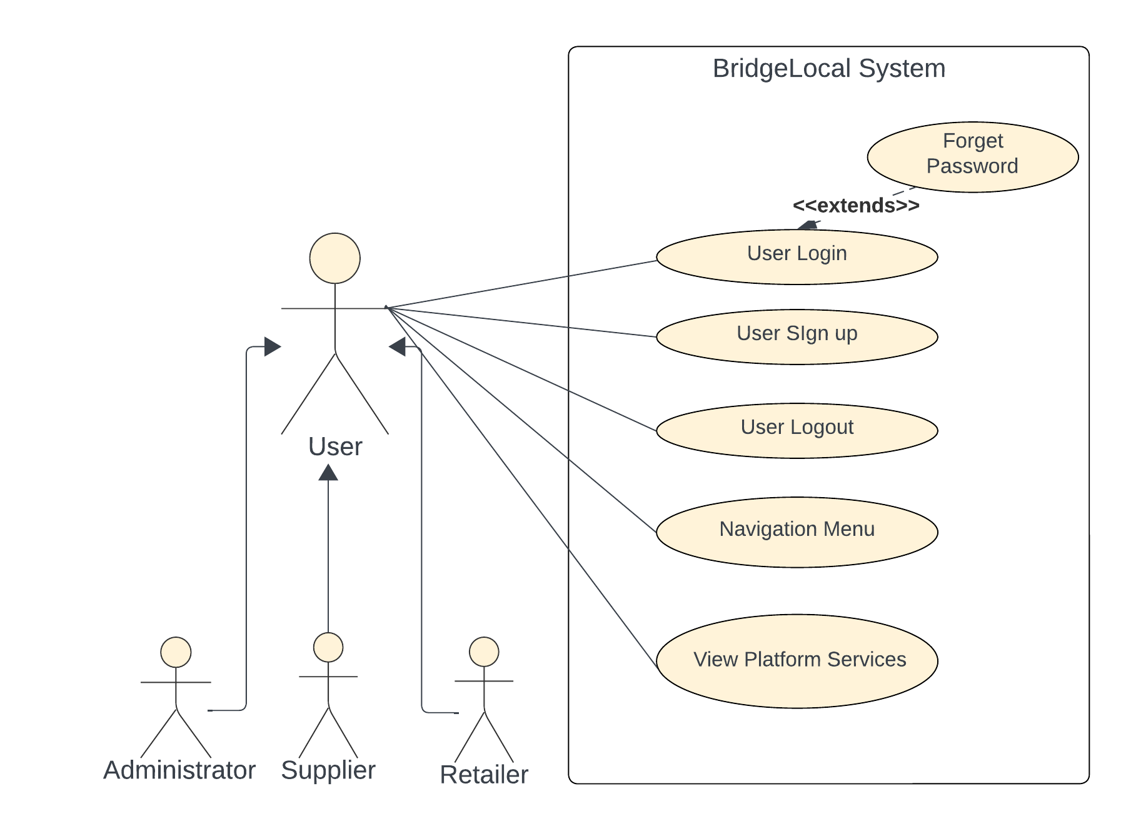

Figure 4.1 Use Case Diagram 1

**Use case:** Forget Password

**Actors:** User (initiator)

**Purpose:** Forget password allows users to change their passwords after authentication

**Overview:** The user is able to change their password after receiving a confirmation email to add a security measure and ensure that no one is trying to access their account, after the confirmation email the user is able to change their password into a new one.

**Type:** Essential

**Cross-Reference:** CFR4

**A typical course of action:**

Table 4.1 Typical Course of Action - Forget Password

|  |  |
| --- | --- |
| **Actor Action** | **System Response** |
| *1. Clicks on forget password* |  |
| *2. Enters their email* | 3. A confirmation email is sent to the user with a link that redirects to the change password page. |
| *4. Enters their new password* |  |
| *5. Saves the new password* | 6. Sends another confirmation email stating that their password has been changed. |

**Alternative Solution:** the user receives an email regarding a password change and discovers that someone is trying to access their account, the user suspecting a malicious activity decides to ignore the email and does not end up changing their password.

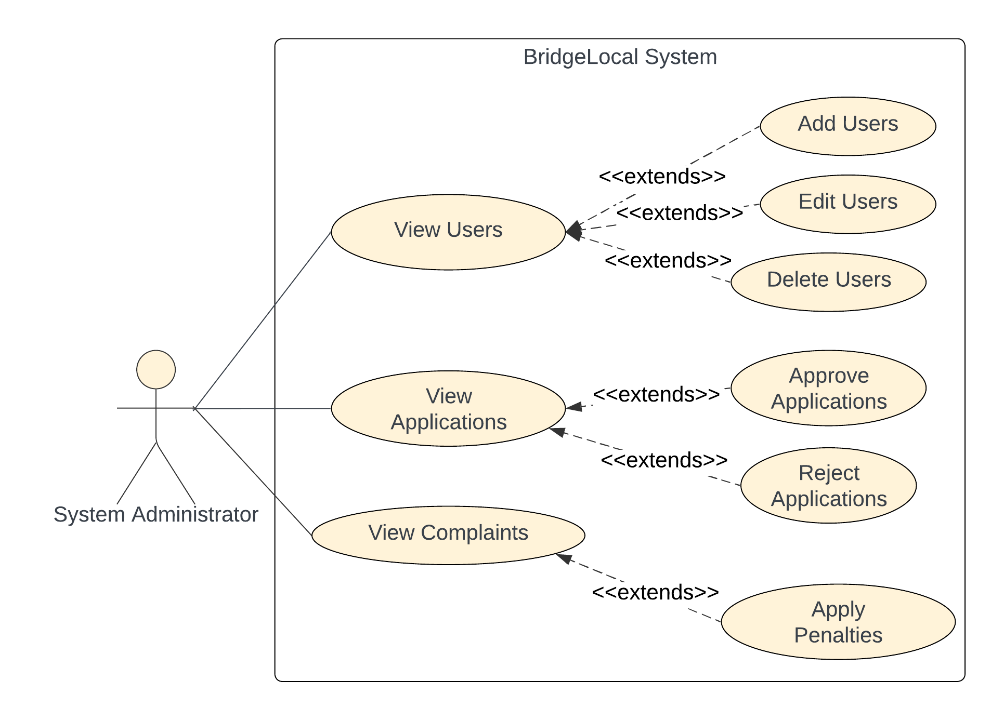

Figure 4.2 Use Case Diagram 2

**Use case:** View Complaints

**Actors:** System Administrator (Initiator), Server

**Purpose:** The purpose of this use case is to enable system administrators to view complaints submitted by customers.

**Overview:** After logging into the system, a system administrator can access the complaints section where they can view all complaints submitted by retailers/suppliers. They can then take appropriate actions based on the nature of the complaints, such as analyzing trends or taking corrective actions.

**Type:** Essential

**Cross-Reference:** SAFR9

**A typical course of action:**

Table 4.2 Typical Course of Action – View Complaints

|  |  |
| --- | --- |
| Actor Action | System Response |
| *1. Navigates to the complaints section of the dashboard.* | 2. Server retrieves complaints from the database and displays a list of complaints. |
| *3. Selects a specific complaint from the list to view details.* | 4. Server retrieves detailed information about the selected complaint and display its details. |
| *5. Reviews the complaint details and analyzes the complaint, including the customer's description and then takes the appropriate actions.* |  |

**Alternative Solution:** the system faces issues while retrieving complaint records from the database or displaying them to the System Admin; it notifies the System Admin about the problem. The system will display an error message explaining the issue then suggest a list of actions for the System Admin to solve the issue. This could include troubleshooting steps like checking database connectivity or verifying system configurations.

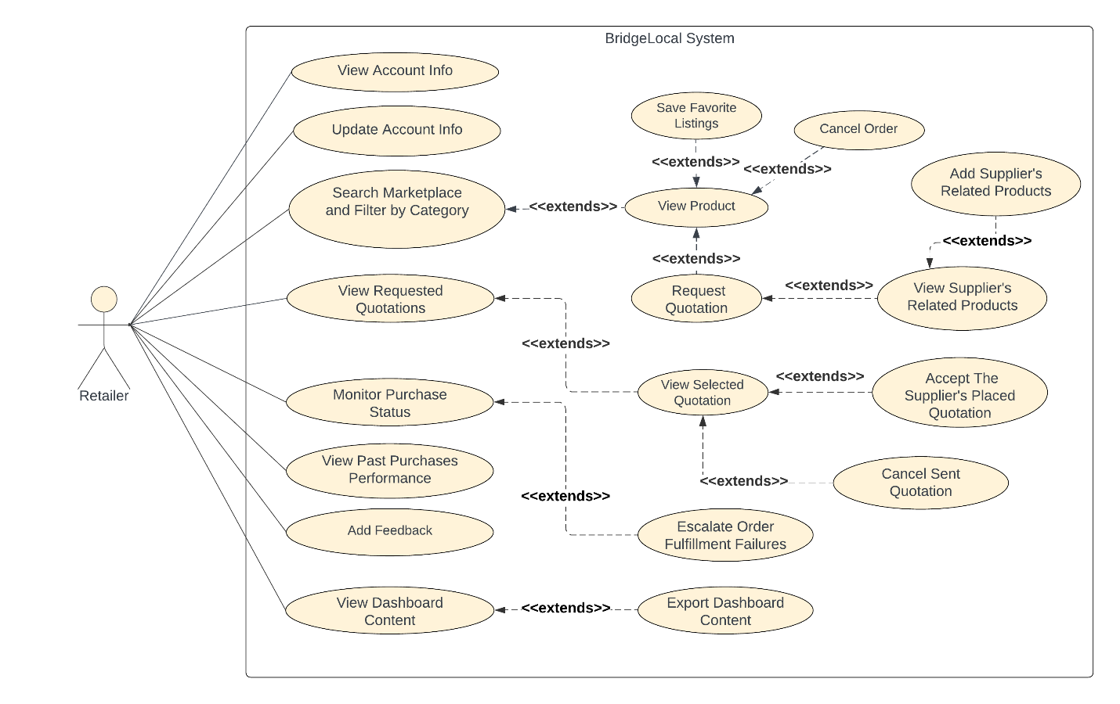

Figure 4.3 Use Case Diagram 3

**Use case:** Request Quotation

**Actors:** Retailer (initiator), Supplier

**Purpose:** The purpose of this use case is to facilitate the request for a quotation from a supplier by the retailer.

**Overview:** After the retailer requests a quotation from supplier, the system processes the request and propagates it to the intended supplier. After the quotation has been received, the system will notify the retailer, enabling them to review the provided information.

**Type:** Essential

**Cross-Reference:** RFR10

**A typical course of action:**

Table 4.3 Typical Course of Action – Request Quotation

|  |  |
| --- | --- |
| Actor Action | System Response |
| *1. Retailer requests quotation from supplier.* | 2. System processes the request and directs it to the intended supplier. |
| *3. Supplier receives the request and prepares a quotation.* |  |
| *4. System will notify the retailer about the completed quotation request.* |  |
| *5. Retailer reviews the provided quotation and takes appropriate action.* |  |

**Alternative Solution:** The system faces issues in processing the request due to incomplete / invalid information provided by the retailer. The system will then notify the retailer about the issue and redirects them to a page to edit the information.

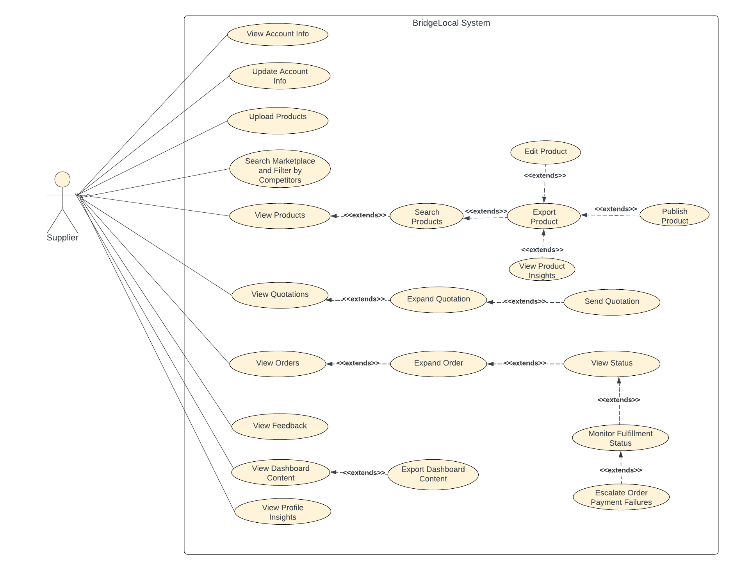

Figure 4.4 Use Case Diagram 4

**Use case:** Send Quotation

**Actors:** Supplier (initiator), Retailer

**Purpose:** The purpose of this use case is to facilitate the sending of quotations from a supplier to retailers.

**Overview:** After the supplier prepares and sends a quotation to intended retailer, the system makes sure processing has been proper and delivers the quotation to the intended recipient.

**Type:** Essential

**Cross-Reference:** SFR12

**A typical course of action:**

Table 4.4 Typical Course of Action – Send Quotation

|  |  |
| --- | --- |
| Actor Action | System Response |
| *1. Supplier prepares and sends a quotation to the intended retailer(s).* | 2. System processes the quotation and forwards it to the intended retailer(s). |
| *3. Receives the quotation from the supplier.* |  |

**Alternative Solution:** If the supplier faces issues while preparing or sending the quotation, the system will notify the supplier about the problem and prompts them to review and edit the quotation before resending it to the intended retailer(s).

#### **4.1.2 Class Diagram**

The class diagram for BridgeLocal shows the arrangement and connections between entities in the system, offering an outline of the platform's design. The User class is an abstract class that acts as a foundation for disjoint user categories including Retailer, Supplier and Administrator. It includes attributes for identification, contact information and account management like: UserID, NationalNumber, Email, Password and PhoneNumber. This diagram also defines methods for user actions, such as verifyEmail, signup, login and forgetPassword.  
  
The Retailer and Supplier classes derive from the User class enhancing it by incorporating further properties and methods that match to their respective functions. for example, the Retailer class provide functionalities for handling orders and quotations like submitting complaints, viewing requested quotations and ordering products. The Supplier class has functionalities for managing products and quotations like viewing products, sending quotations and editing / uploading product details. Both classes enable features like submitting complaints, accessing dashboards and exporting dashboard content.  
  
The Administrator class, which also inherits from User, possesses administrative capabilities such as user management (addUser, editUser, removeUser) and complaint handling (viewComplaints, applyPenalty).

The user classes are closely interconnected with additional classes such as Product, Order, Quotation, and Complaints to make the fundamental functions of the platform possible. The Product class contains properties for product details and associations with analytics, whereas the Order class handles order specific data. The Quotation class establishes a connection between retailers and suppliers by utilizing properties such as QuotationID, CompanyName, and OrderList. The Complaints and ComplaintsType classes manages the process of submitting complaints and categorizing them will make accurate tracking of issues easier.  
  
Additional extra classes such as Analytics, Logs, Inventory, Penalty, and Review enhance the functionality and data management of the platform. Enumerations such as PenaltyEnum, UserStatus, and PurchaseStatus offer configurable values to ensure consistency.  
  
This diagram offers a coherent and organized illustration of the system, outlining the essential properties, methods and relationships required to provide the platform's functionality and business logic. This holistic design guarantees an adaptable solution for linking local manufacturers with retailers; thus promoting local products and a collaborative market.

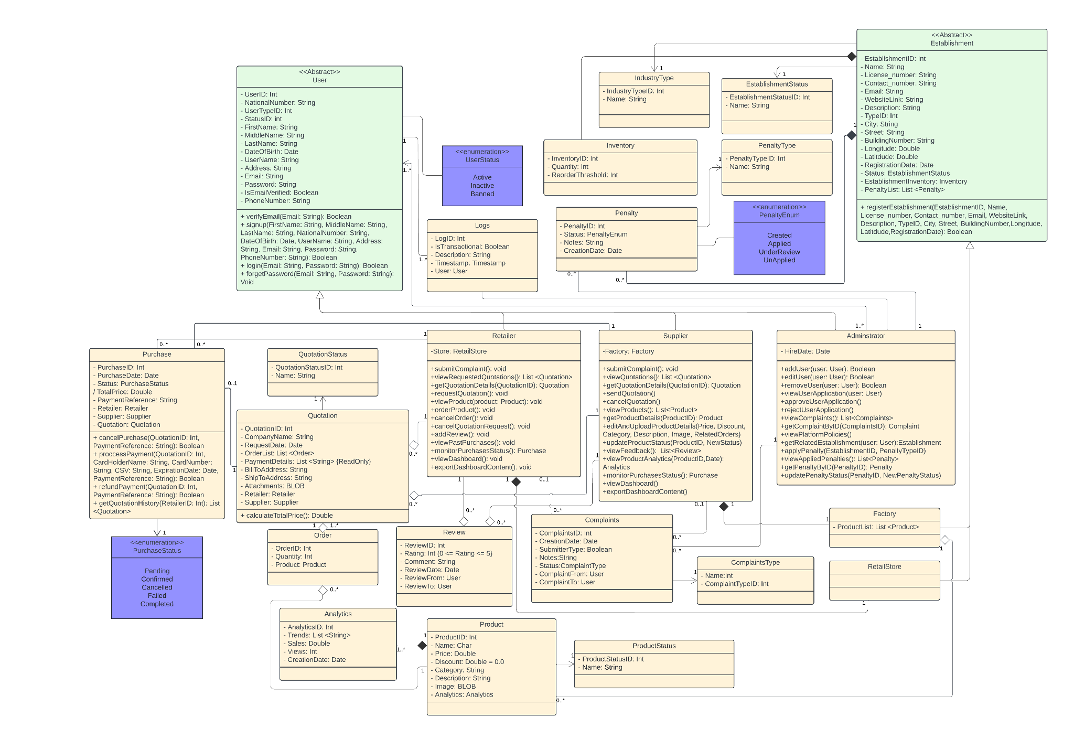Figure 4.5 Class Diagram

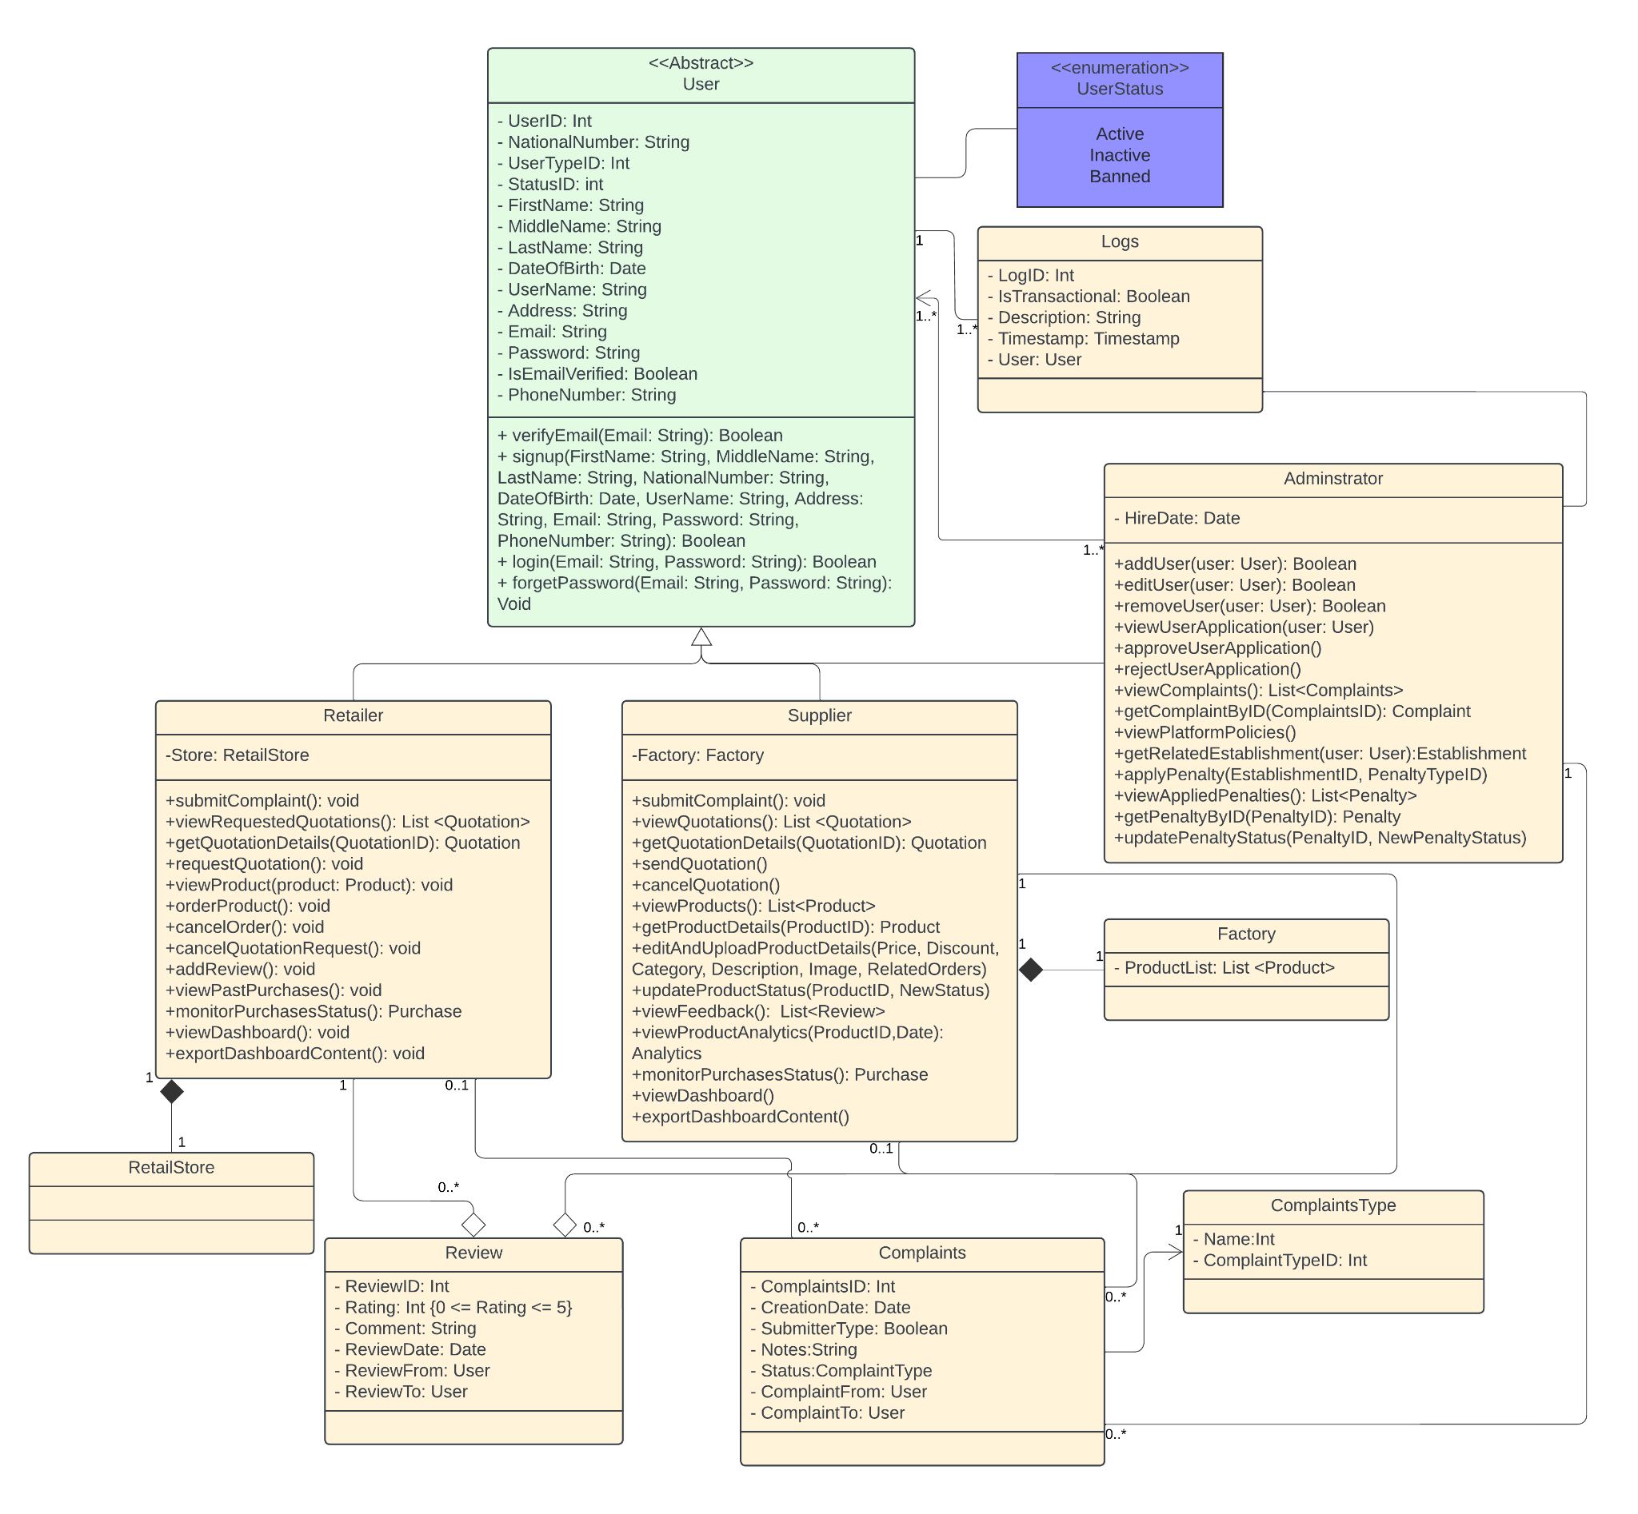

Figure 4.6 Class Diagram - Part1

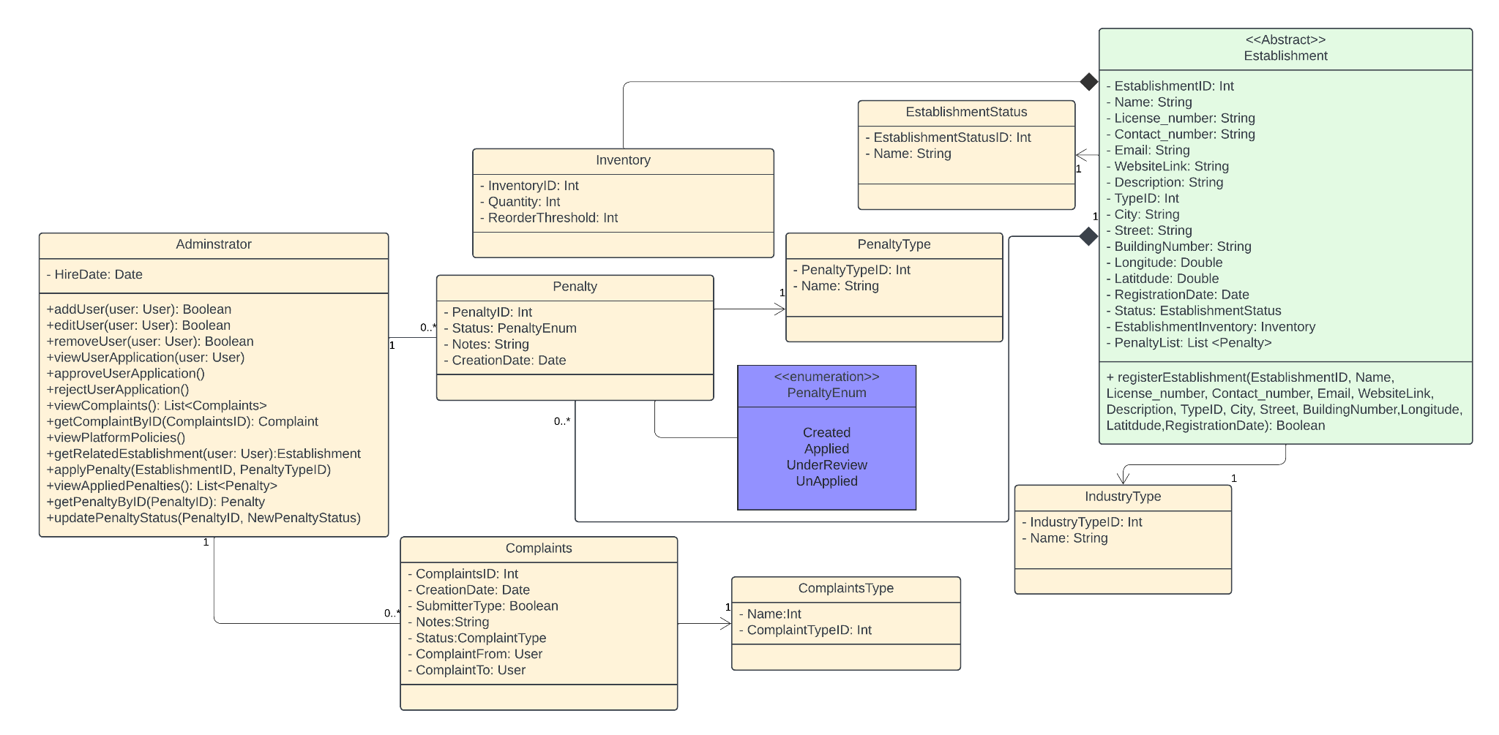

Figure 4.7 Class Diagram - Part2

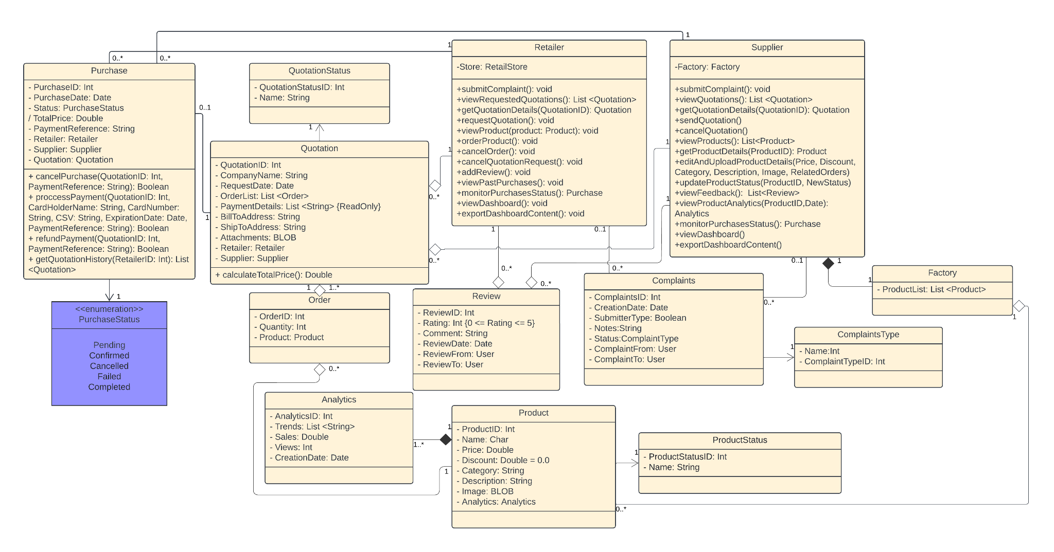

Figure 4.8 Class Diagram - Part3

#### **4.1.3 Object Diagram**

The figure below Figure 4.9 illustrates an instance of the class diagram. It provides specific information regarding an administrator by the name of "Ali Ahmad" who applied a type 2 penalty to an establishment by the name of "UTLIndustries" in response to a supplier complaint from the retailer.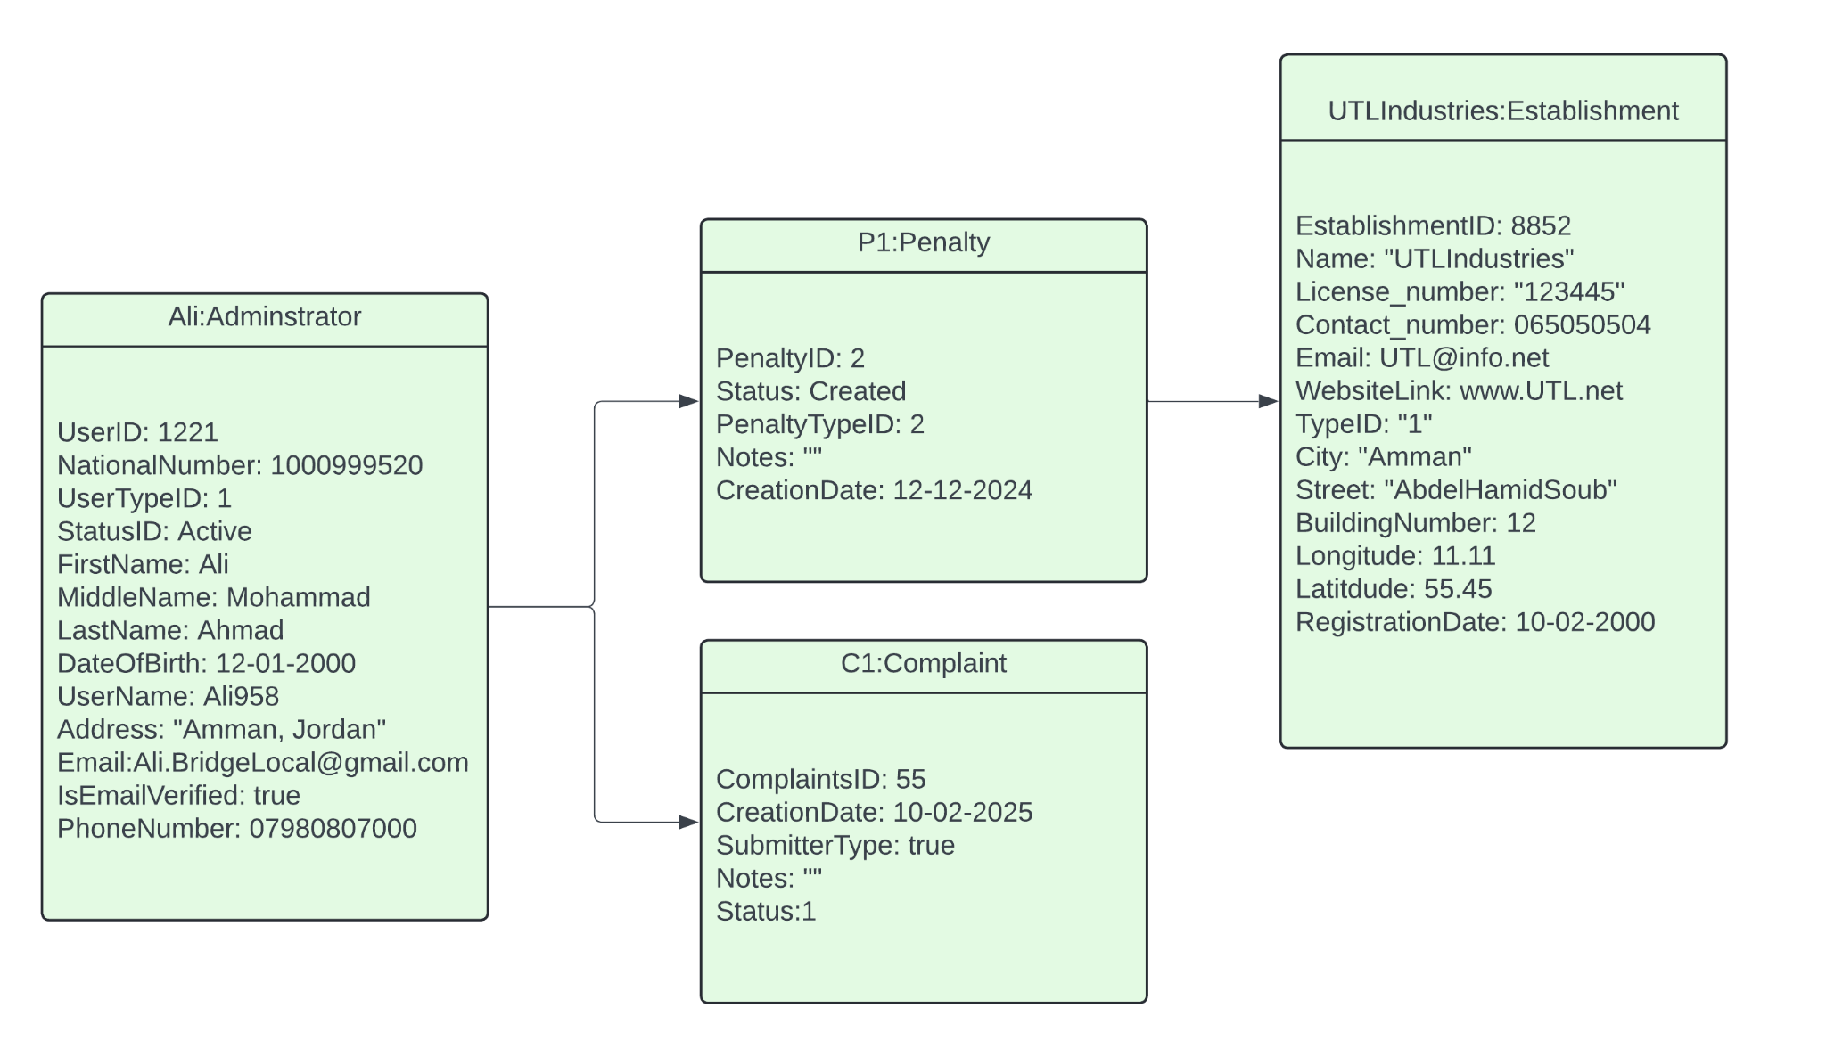

Figure 4.9 Object Diagram 1

The figure below Figure 4.10 illustrates an instance of the class diagram. It provides specific information regarding a retailer by the name of "Jawad Ismael" who gave a review to the supplier by the name of “Ahmad Jarrar” with a rating 2 and the comment “Bad Fulfillment Dates”.

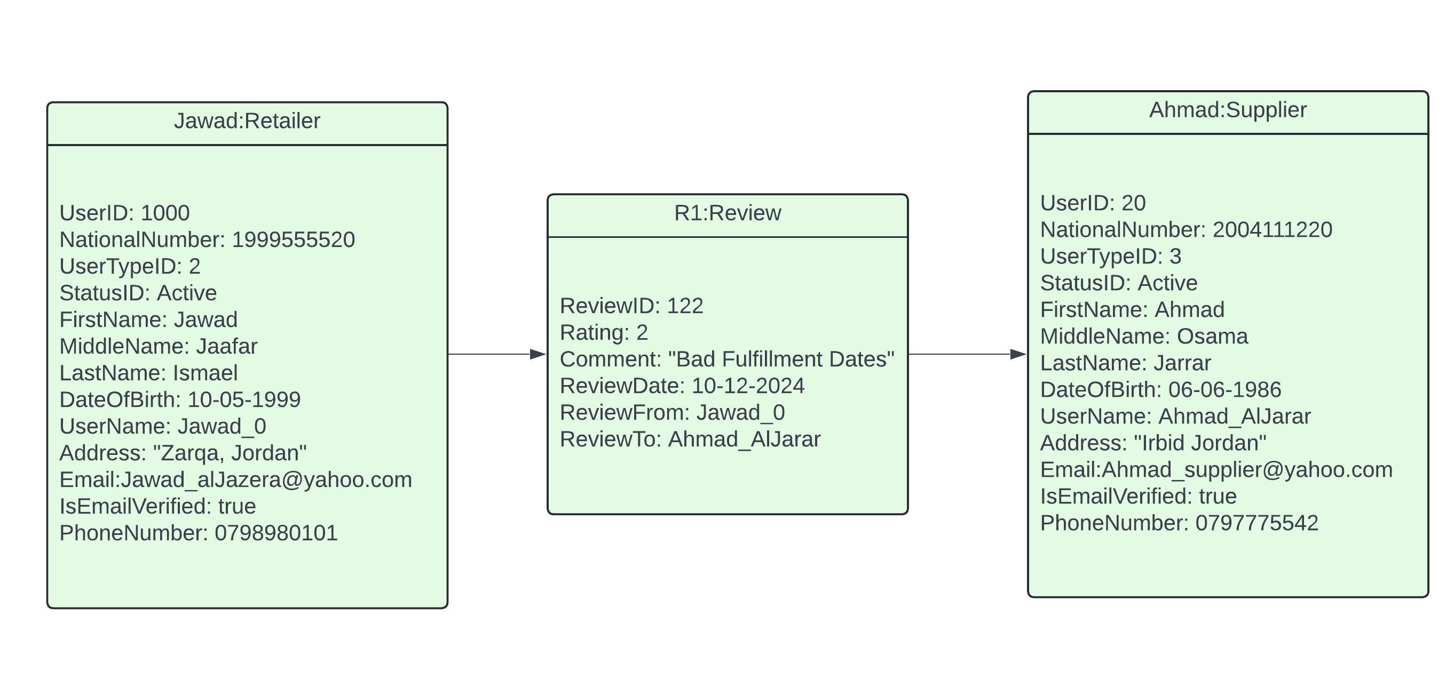

Figure 4.10 Object Diagram 2

#### **4.1.4 Package Diagram**

The first package diagram illustrated in Figure 4.11 shows the package “Users” and imported from it three other packages: “Doctor”, “Patient”, and “Potential Patient.”

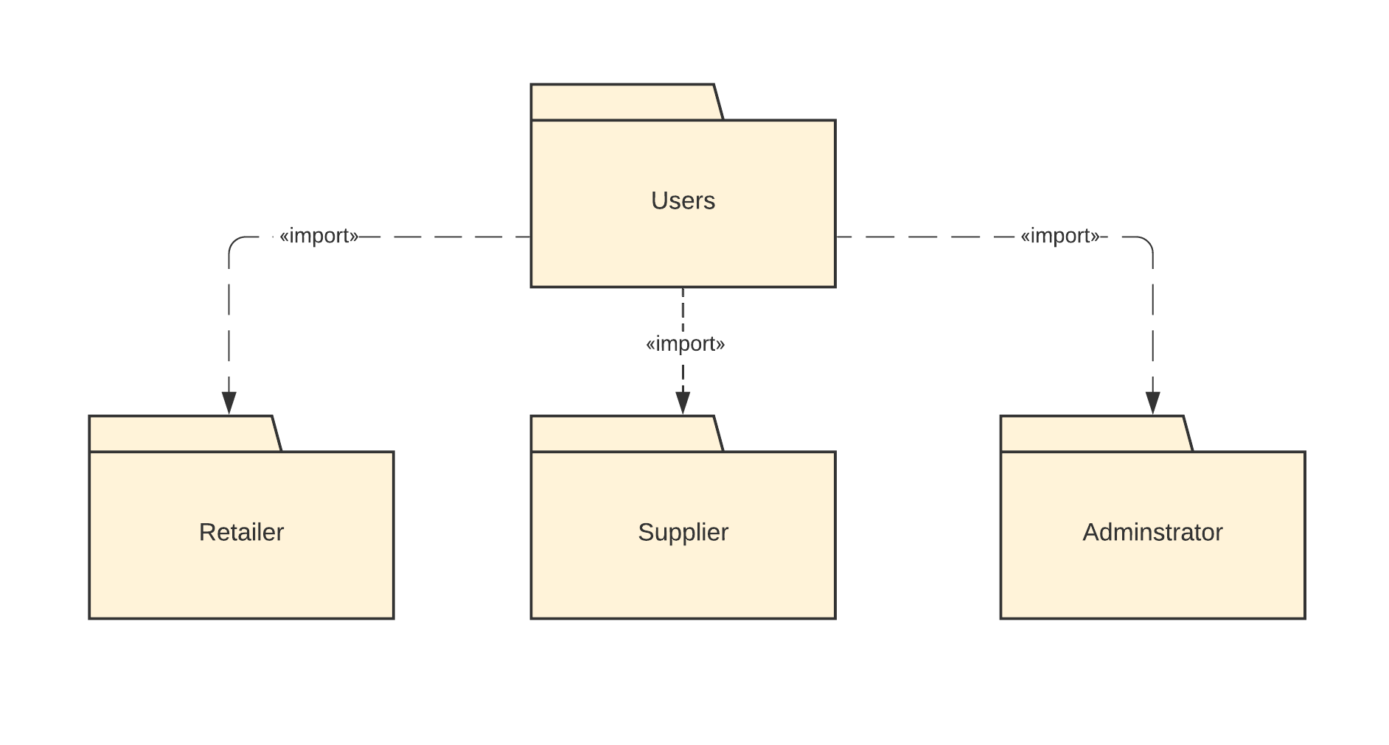

Figure 4.11 Package Diagram 1

The second package diagram illustrated in Figure 4.12 shows "User Management" merging with "Supplier," "Retailer," and "Administrator." It imports from "Platform," which imports from "Product Management." "Order Management" merges with "Order" and "Quotation," and accesses "Data collection/analytics." This detailed view highlights the interactions and dependencies among user management, order management, product management, and data analytics within the BridgeLocal system.

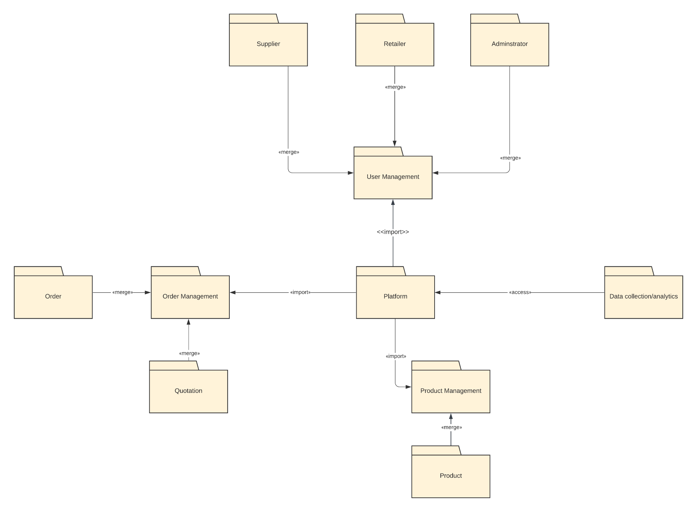

Figure 4.12 Package Diagram 2

#### 

#### 

#### 

#### 

#### **4.1.5 Component Diagram**

The figure below Figure 4.13 represents the component diagram of the system.

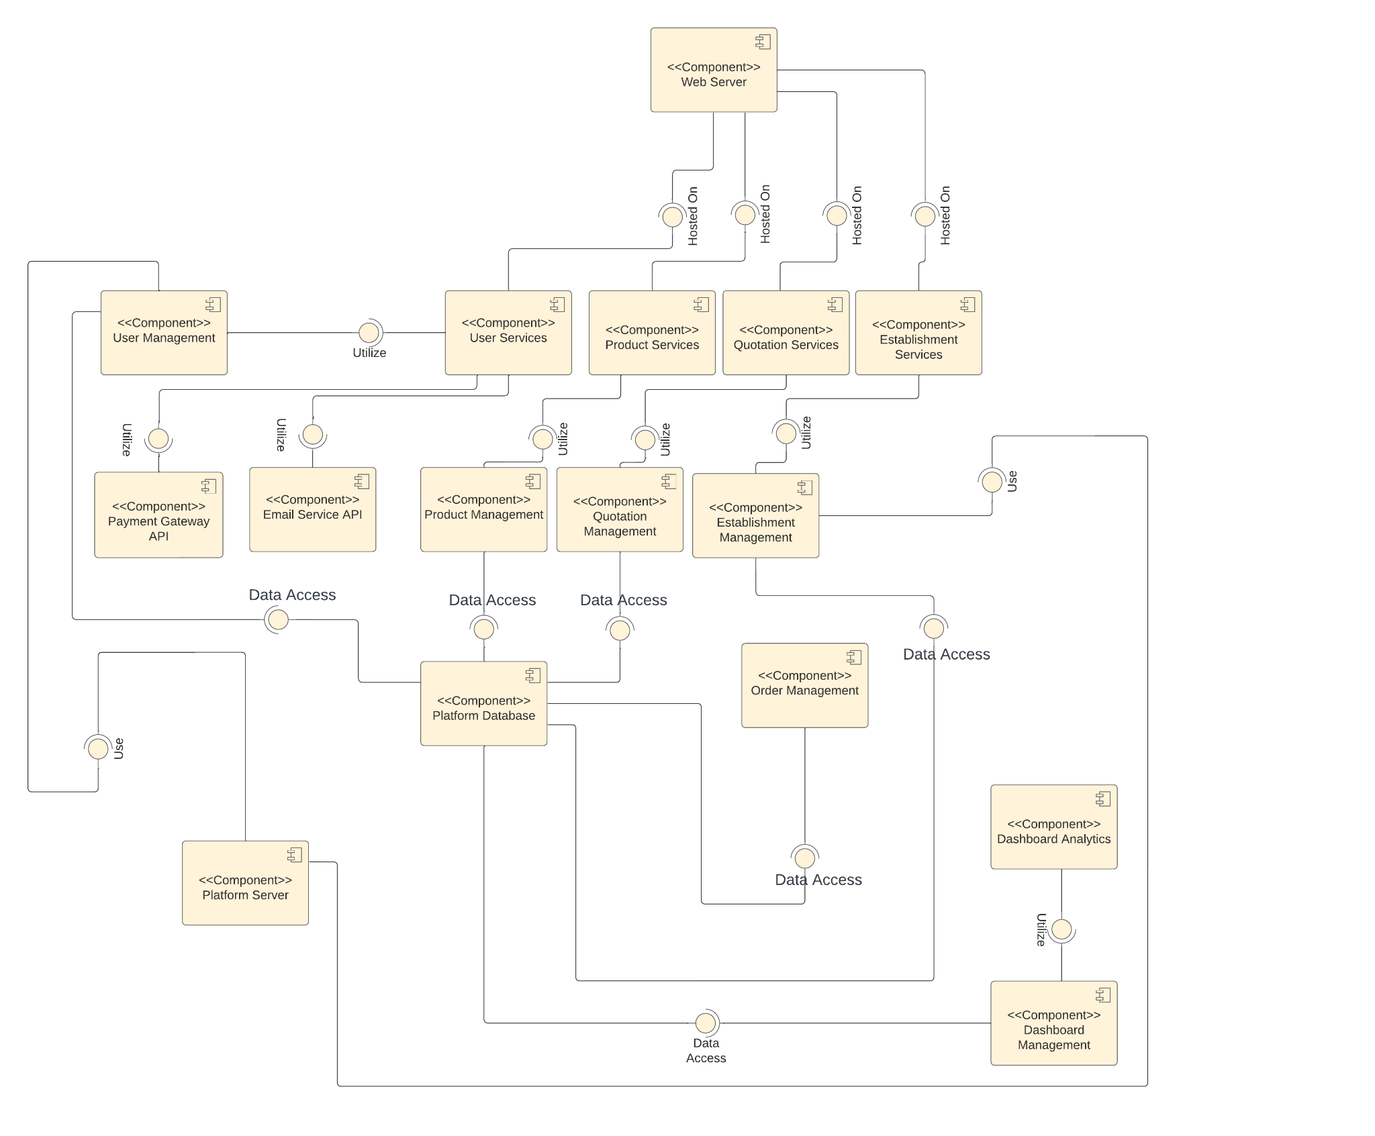

Figure 4.13 Component Diagram

#### **4.1.6 Deployment Diagram**

The figure below Figure 4.14 refers to the deployment diagram of the system, and it depicts how the hardware and software components interact with each other.

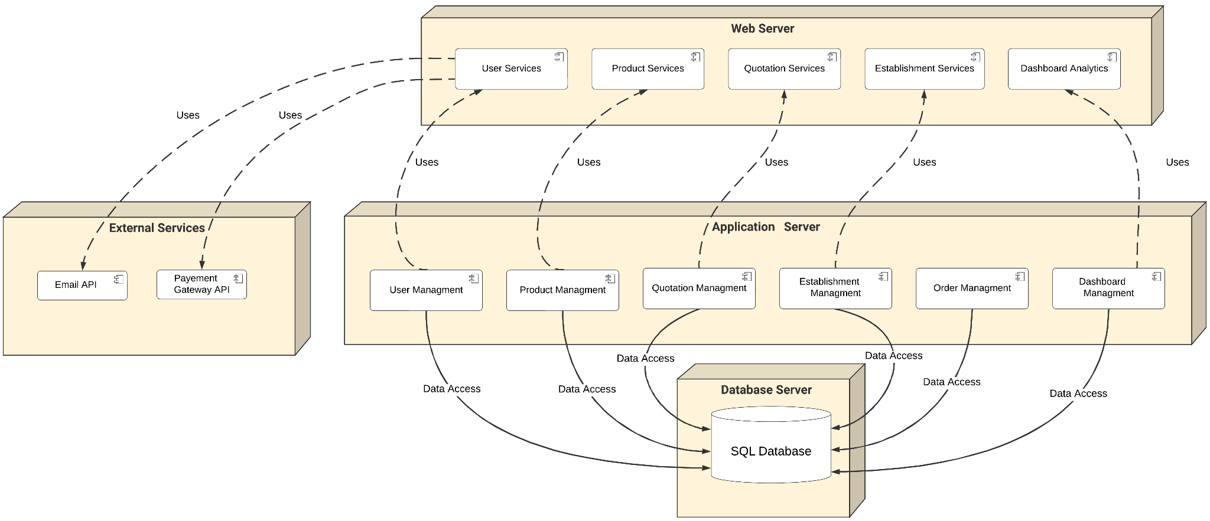

Figure 4.14 Deployment Diagram

#### 

#### 

#### 

#### 

#### 

#### 

#### 

#### **4.1.7 Activity Diagram**

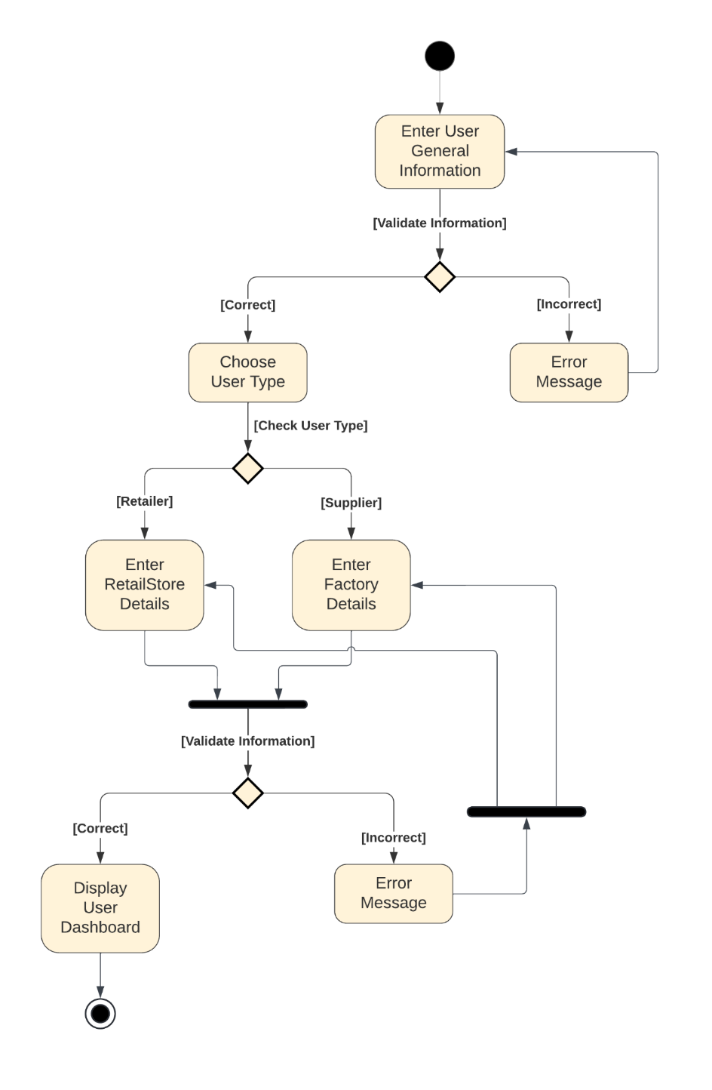The figure below Figure 4.15 shows the activity diagram for the “Create User” process, which starts when the user enters their general information. If there’s an error, it displays to the user an error indicating the error. If the information is valid, then the user should choose his type (retailer or supplier) and after that, the user enters their establishment’s details, If the data is valid, the system switches the user to their dashboard; if not, an error message pops up for the user.

Figure 4.15 Activity Diagram 1

The figure below Figure 4.16 shows the activity diagram for the “Request Quotation” process, which starts when the retailer logs in their account and searches the marketplace for a specific product, after selecting the product, the retailer requests a quotation and sends it to the supplier, and then the supplier responds to the sent quotation and sends it back to the retailer to review it. After reviewing the quotation, they may accept and order it or reject the order.

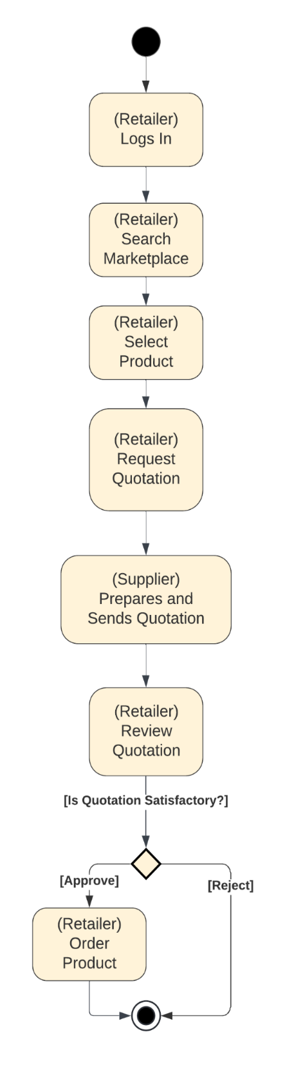

Figure 4.16 Activity Diagram 2

The figure below Figure 4.17 shows the activity diagram for “Applying Penalties” from the admin, which starts when the admin logs in to their account and selects to view the complaints, then views a specific complaint and checks the policies to see if the complaint violates the policies or not, if it violates, then the admin applies a penalty to the establishment complained about, if no policy is violated, the complaint gets canceled

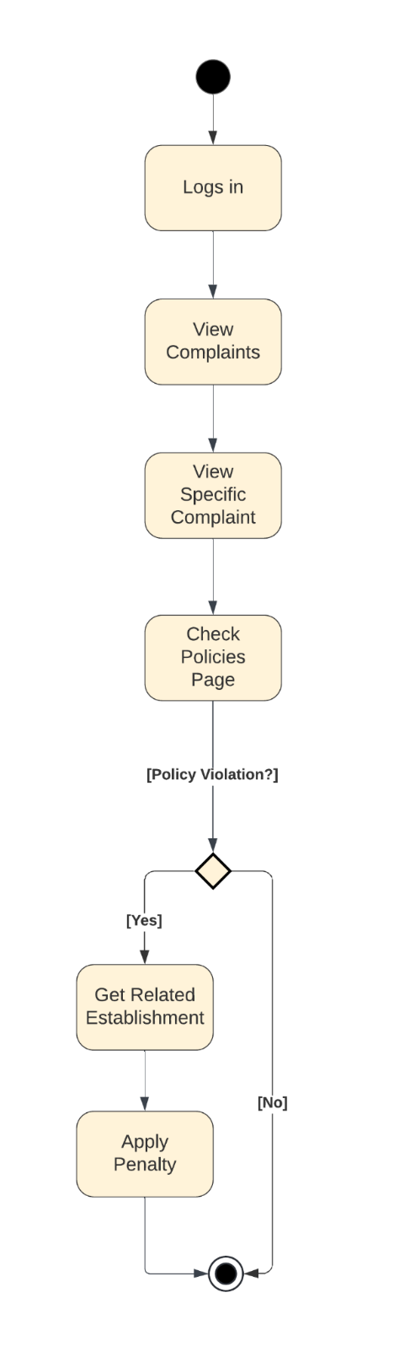

Figure 4.17 Activity Diagram 3

#### **4.1.8 Sequence Diagram**

The figure below Figure 4.18 shows the “Application Submission” Process, which starts when the user (retailer or supplier) submits their application to the system, then the admin reviews this specific application, and then the admin may accept the application or reject it and notify the user with the response.

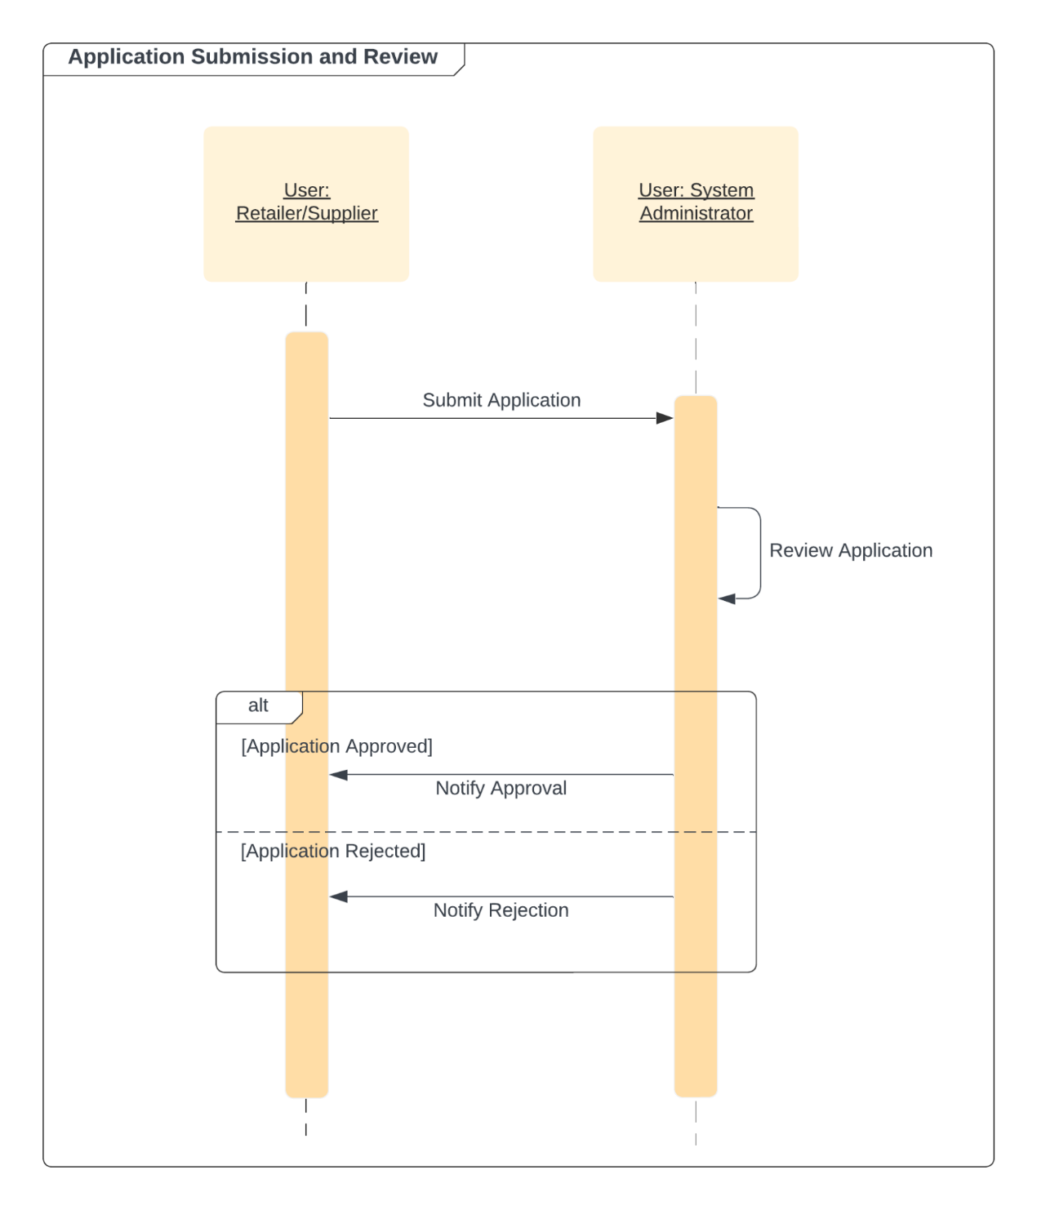

Figure 4.18 Sequence Diagram 1

The figure below Figure 4.19 shows the “Feedback Submission” Process, which starts when the retailer submits a feedback to the database about a specific supplier, the the database notifies the supplier that they received a feedback, the supplier retrieves the feedback from the database then the database shows it to the supplier.

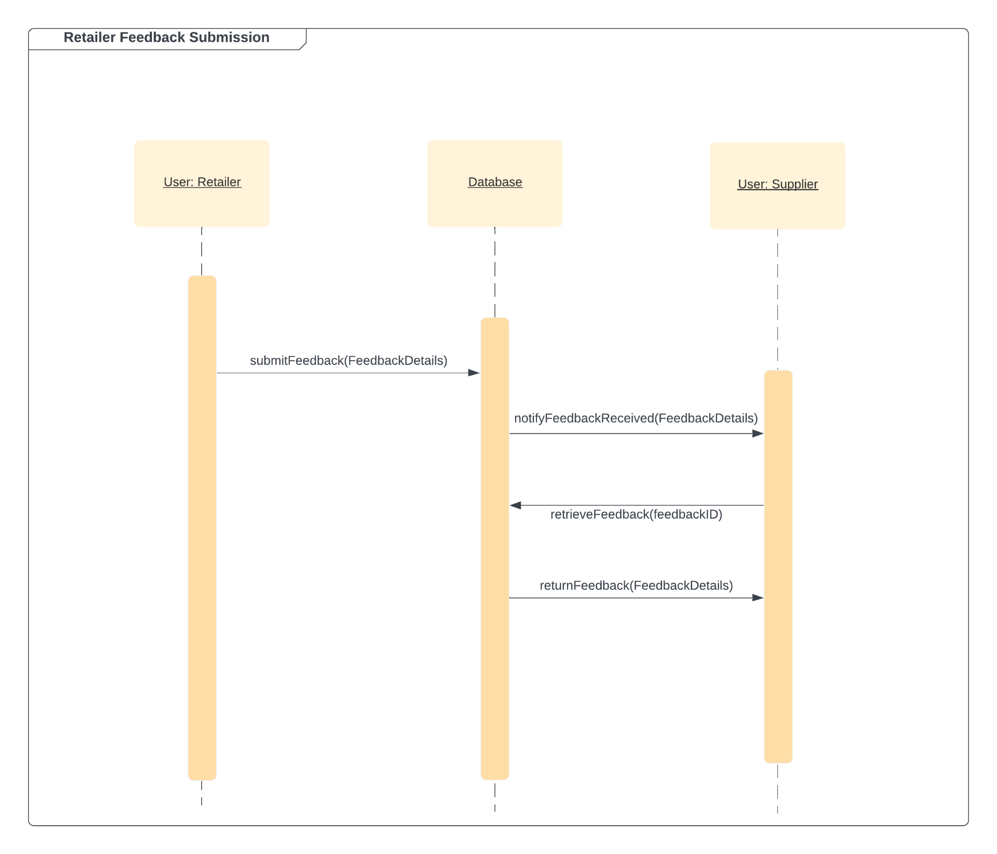

Figure 4.19 Sequence Diagram 2

#### **4.1.9 State Transition Diagram**

The figure below Figure 4.20 shows the state diagram for “Complaint status”, A complaint begins in the "Created" state and moves to "Under Review." If the complaint violates policies, it changes to "Applied." If it does not violate policies, it moves to "Unapplied."

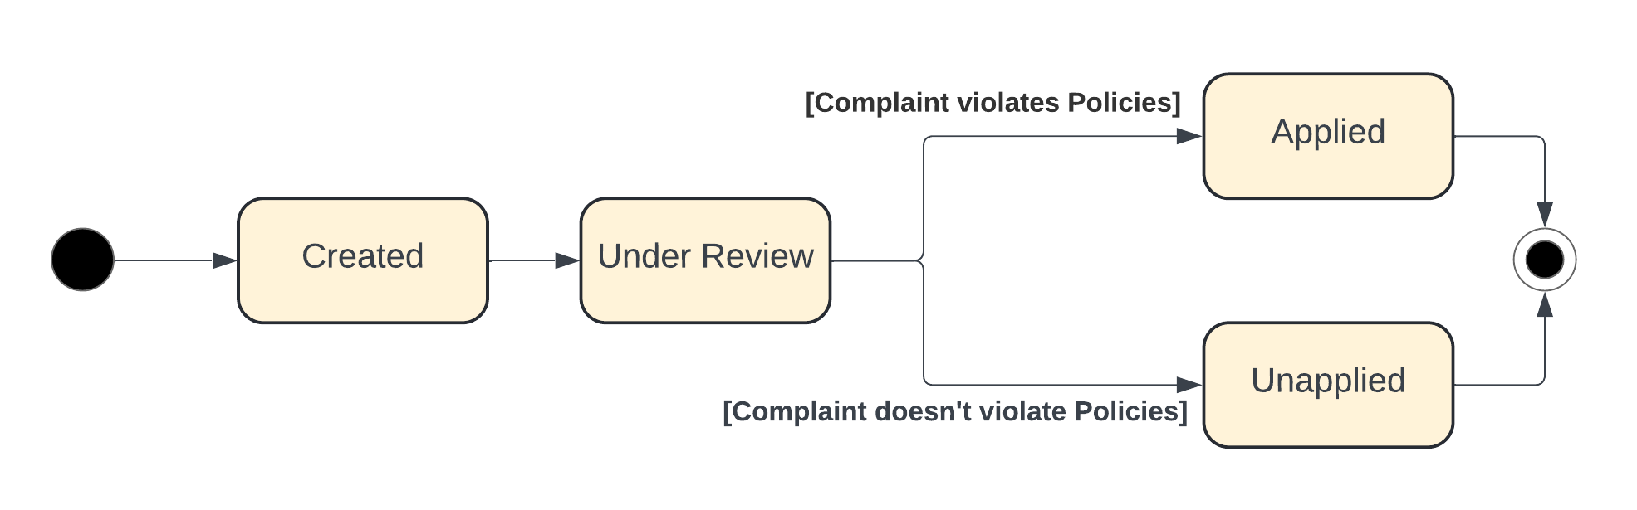

Figure 4.20 State Diagram 1

The figure below Figure 4.21 shows the state diagram for the “User status”, A user can be "Active", "Inactive" or "Banned". An account moves to "Inactive" if the user deactivates it, and can return to "Active", if reactivated. If a banning penalty is applied, the status changes to "Banned." An admin can lift the ban to return the account to "Active." If a user remains inactive for a long time after being banned, the account remains "Banned".

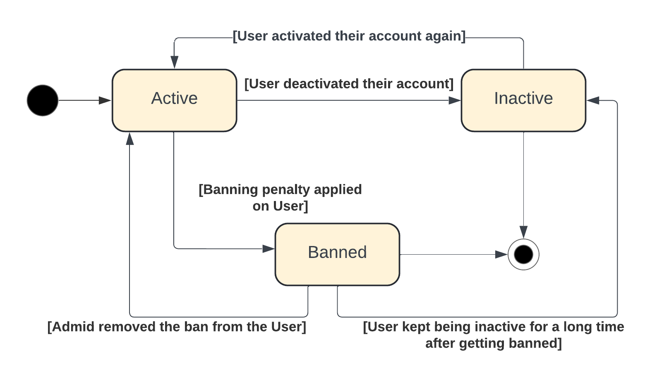

Figure 4.21 State Diagram2

### **4.2 Physical Model Design**

#### **4.2.1 Database Design**

##### **4.2.1.1 Database Entity Relationship Diagram**

The figure below Figure 4.22 shows the ER diagram for BridgeLocal details a comprehensive data structure by defining various entities and their relationships within the system. The "User" entity is central and includes attributes like UserID, Username, Password, Email, Phone Number, DOB, Age, Full Name, StatusId, IsEmailVerified, and NationalNumber. Users can take on specific roles, such as Supplier, Retailer, or Administrator. This setup supports diverse functionalities by linking users to orders, quotations, products, reviews, analytics, establishments, inventory, penalties, and complaints.

The "Order" and "Quotation" entities are interconnected, with OrderID, RequestedDate, Quantity, TotalPrice, ShipToAddress, BillToAddress, and PaymentDetails attributes for orders, and QuotationID, RequestedDate, TotalPrice, and Status for quotations. The "Product" entity includes ProductID, Name, Description, Price, Image, Discount, and Status and is linked to inventory and categories. Additionally, the "Review" entity captures user feedback on products through attributes like ReviewID, Rating, Comment, and ReviewDate, demonstrating the system's capability to handle product reviews and analytics.

The "Establishment" entity encompasses EstablishmentID, Name, Description, TypeID, ContactNumber, WebsiteLink, Email, Address, OperatingHours, RegistrationDate, and LicenseNumber, and it owns the "Inventory" entity. Inventory management is detailed with attributes such as InventoryID, QuantityAvailable, and ReorderThreshold, which connect to the products. The system also addresses regulatory and operational compliance through entities like "Penalty" and "Complaint," which include PenaltyID, Notes, CreationDate, and Status for penalties, and ComplaintID, Notes, CreationDate, and Status for complaints.

Supporting entities like "EstablishmentStatus," "QuotationStatus," "ProductStatus," "PenaltyType," "ComplaintType," and "IndustryType" provide additional granularity in status tracking and categorization. Address attributes for establishments further include BuildingNumber, Street, City, Latitude, and Longitude. This ER diagram effectively maps out the intricate relationships and data flows within the BridgeLocal platform, illustrating how user management, order processing, product handling, review tracking, analytics, and establishment management are integrated to provide a robust system for local producers and retailers.

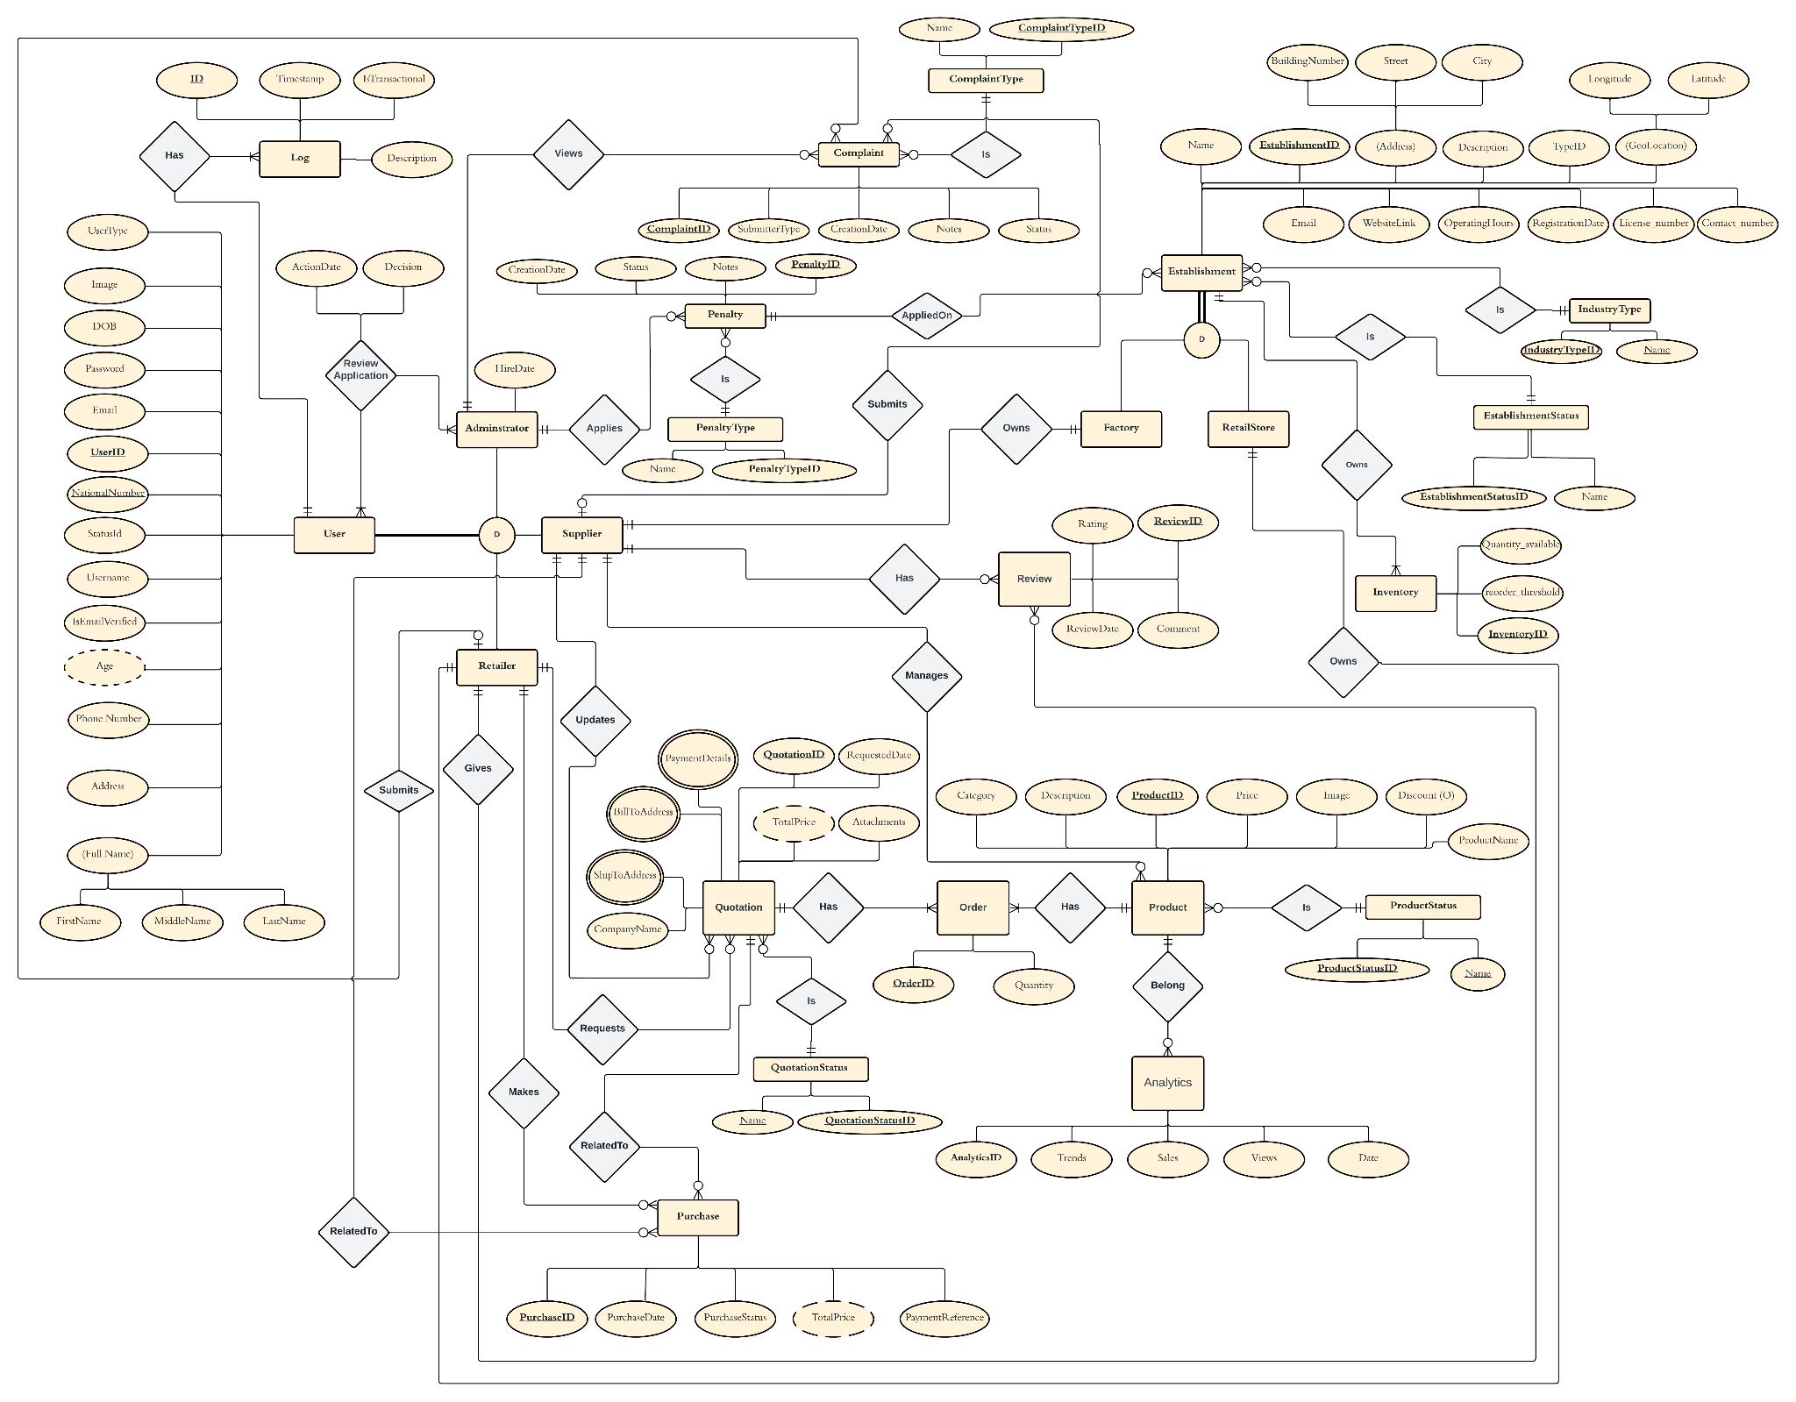

Figure 4.22 Entity Relationship Diagram

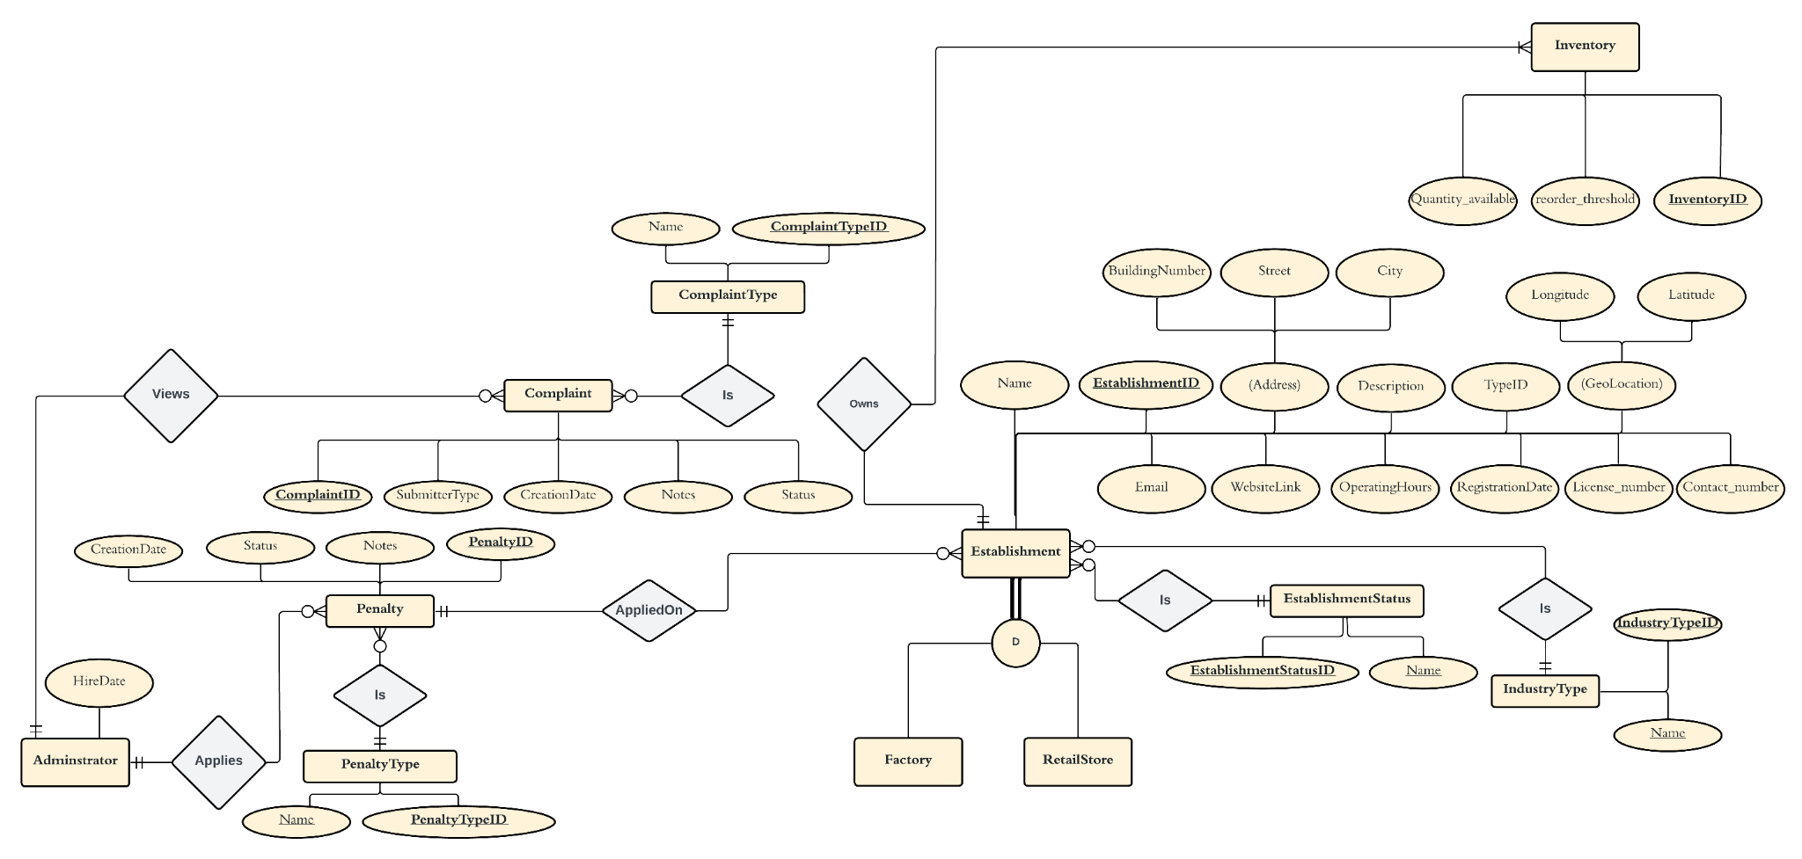

Figure 4.23 Entity Relationship Diagram - Part1

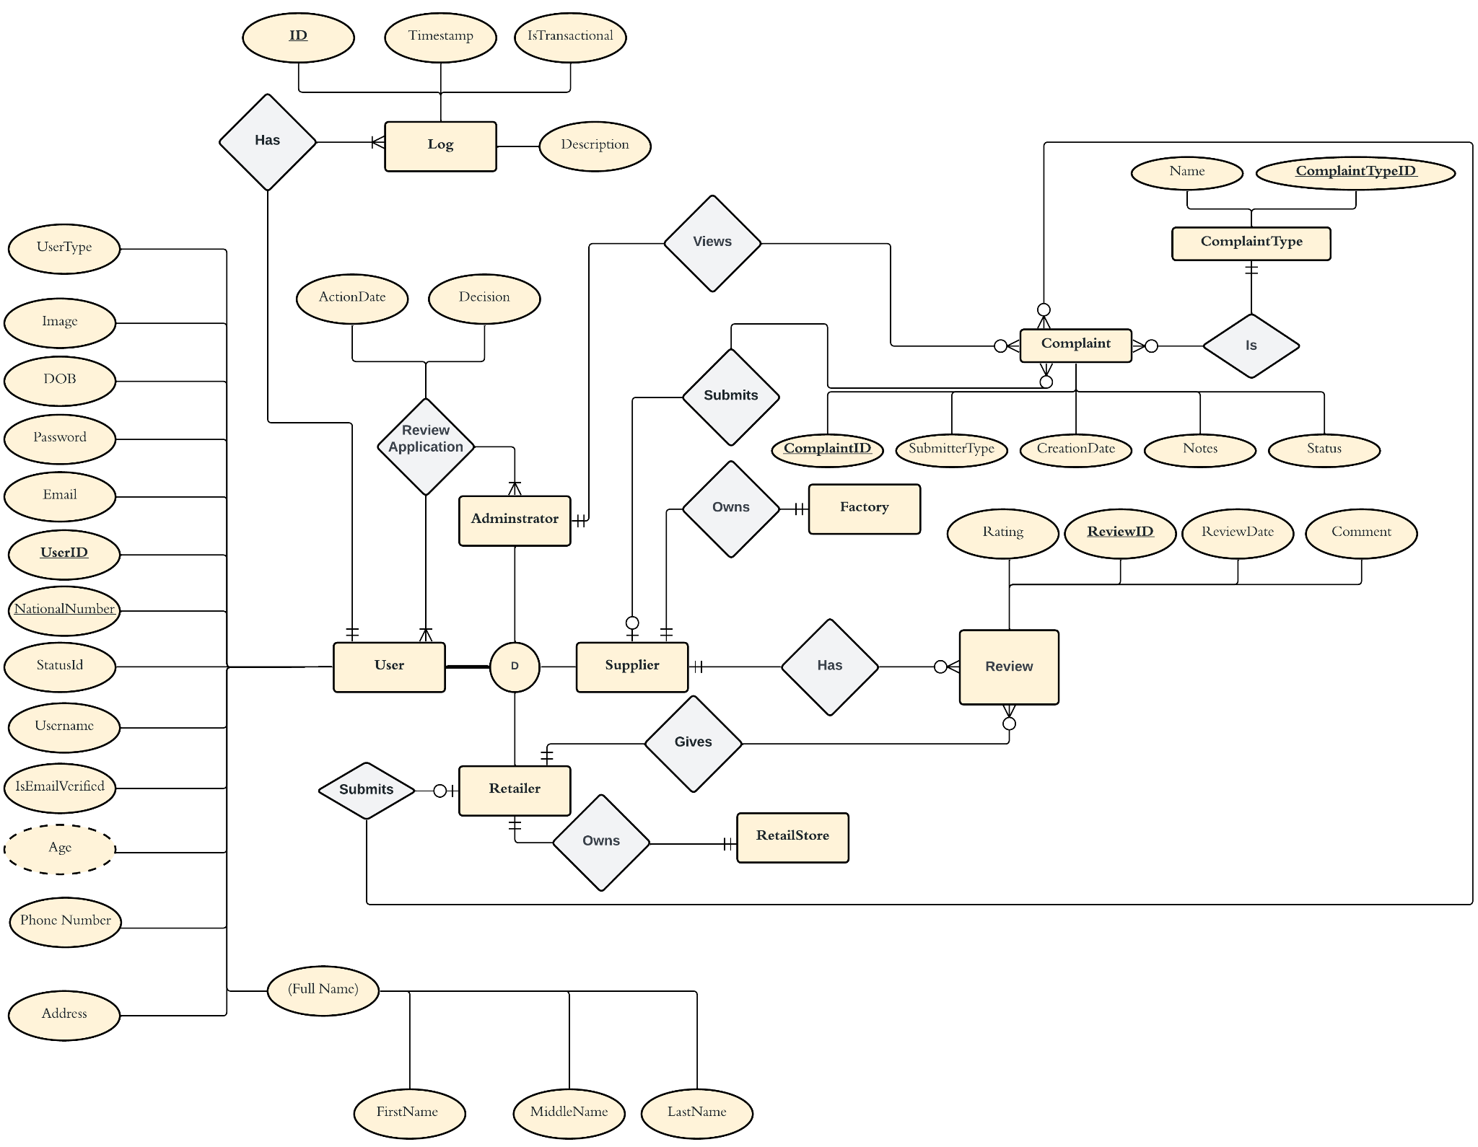

Figure 4.24 Entity Relationship Diagram - Part2

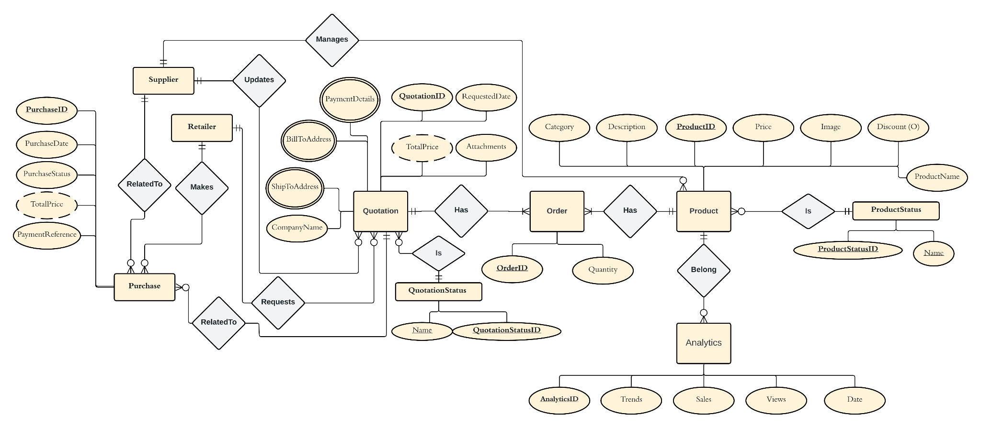

Figure 4.25 Entity Relationship Diagram - Part3

##### **4.2.1.2 Database Schema**

The figure below Figure 4.26 represents the database schema, there are 24 tables overall, and the diagram below illustrates the relationships between each table and also shows the attribute types to be employed.

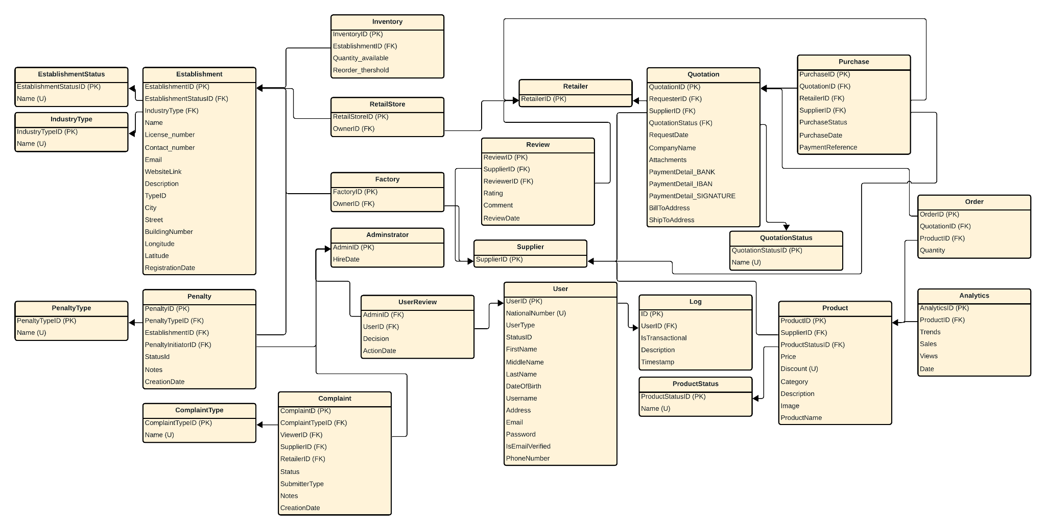

Figure 4.26 Relational Schema

#### 

#### **4.2.2 User Interface Design**

The following figures illustrate how the interface is expected to be. Our easy-to-use interface can be seen as part of our prototype where all the key elements are clear for the user to maximize the functionality of the system.

The figure 4.27 below shows the landing page of our website. A call to action button is included to take the user to the sign up page.

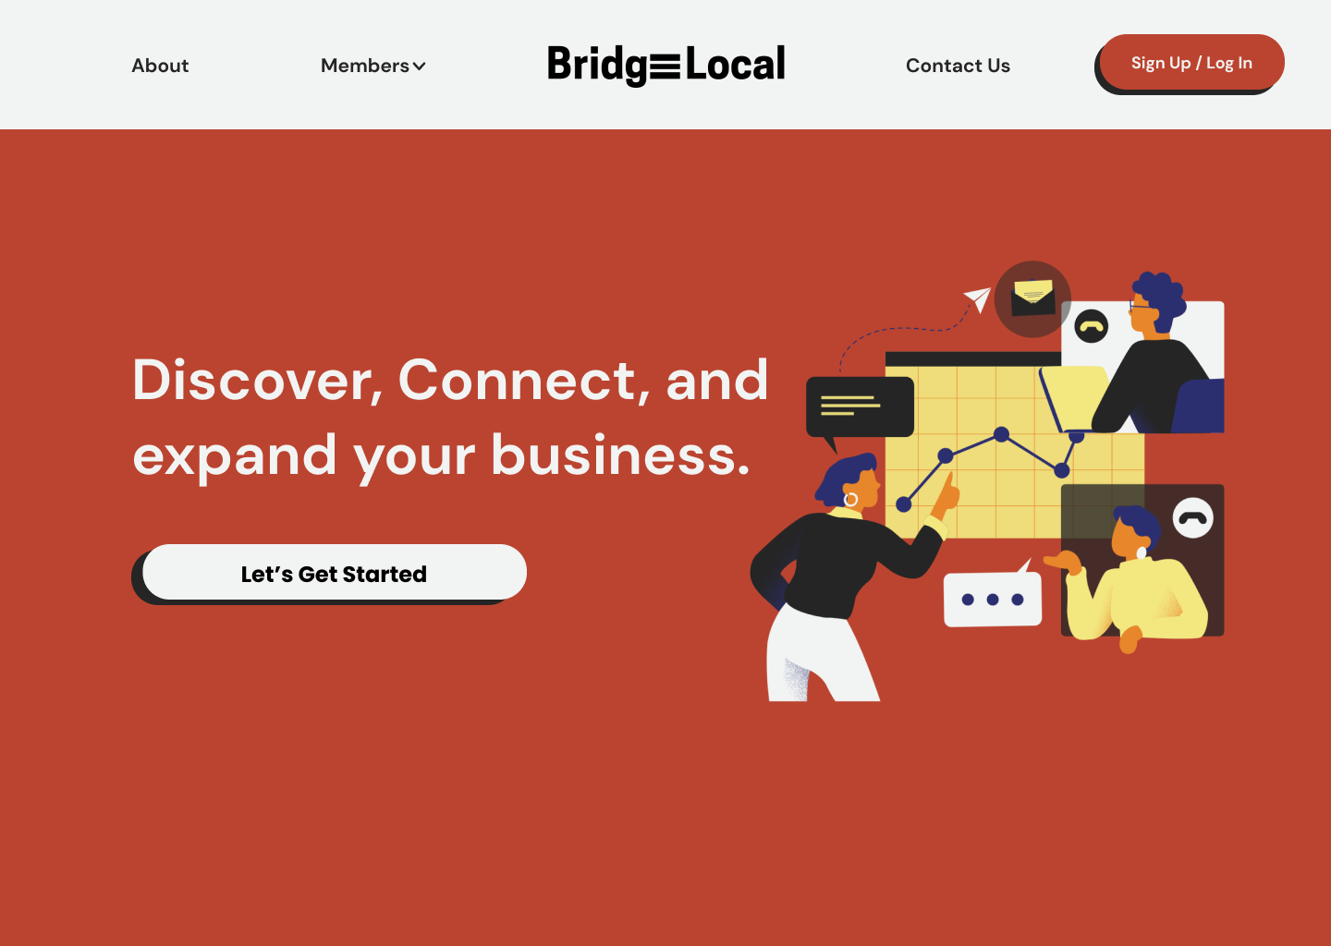

Figure 4.27 BridgeLocal - Landing Page

The figure 4.28 below shows the log in page of our website. A further call to action is added in case the user is not registered yet

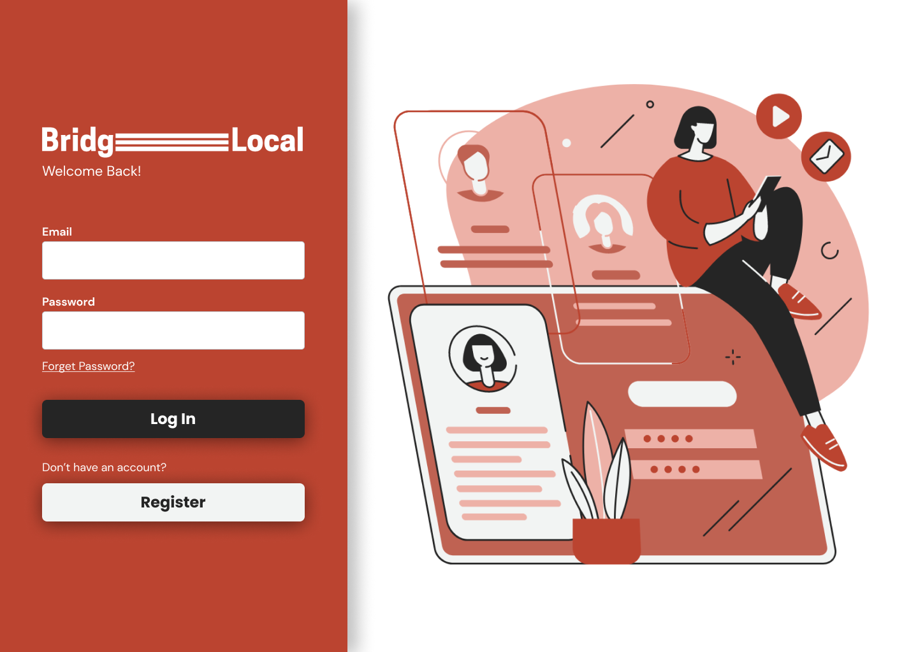

Figure 4.28 BridgeLocal – Log in Page

The figure 4.29 below shows the Retailer Dedicated Sign up page (1).

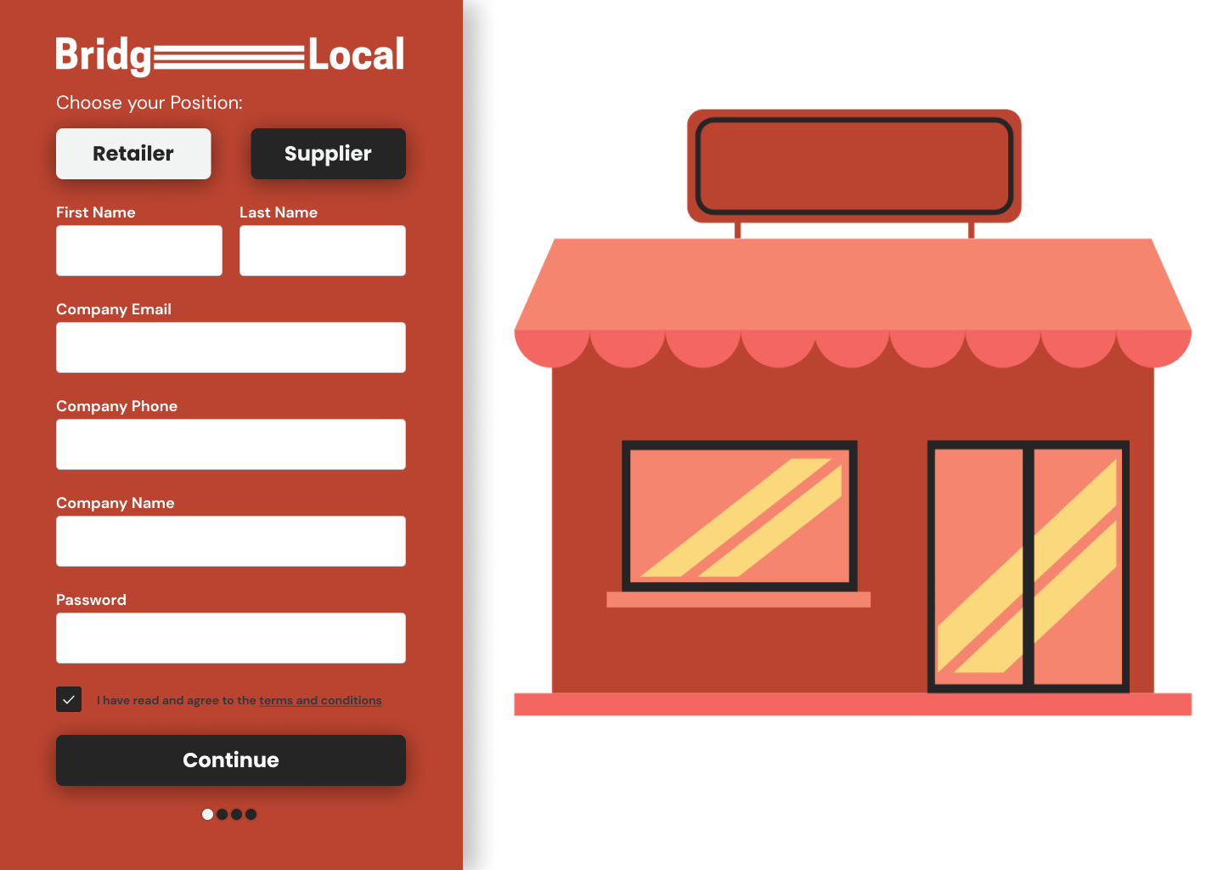

Figure 4.29 BridgeLocal – Retailer Sign up Page (1)

The figure 4.30 below shows the Retailer Dedicated Sign up page (2).

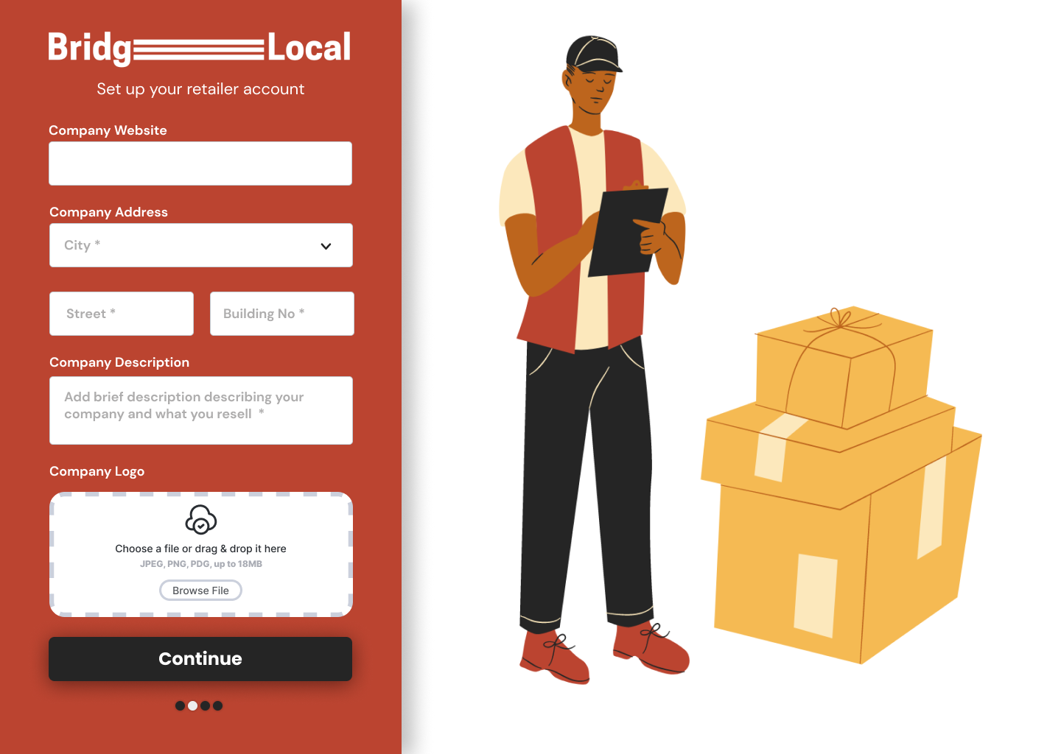

Figure 4.30 BridgeLocal – Retailer Sign up Page (2)

The figure 4.31 below shows the Retailer Dedicated Sign up page (3).

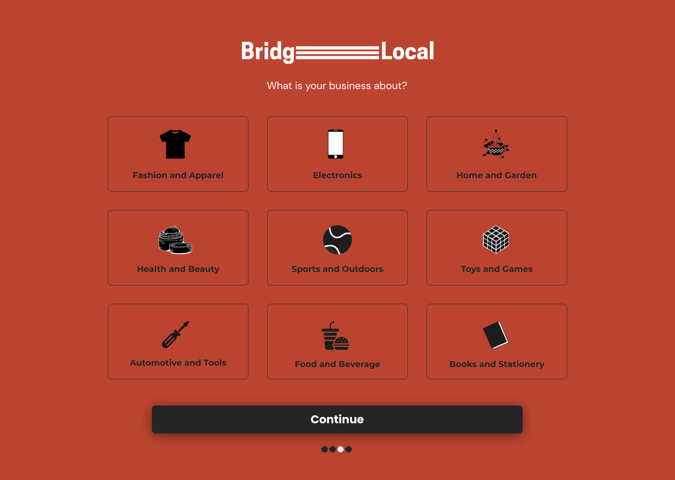

Figure 4.31 BridgeLocal – Retailer Sign up Page (3)

The figure 4.32 below shows the Supplier Dedicated Sign up page (1).

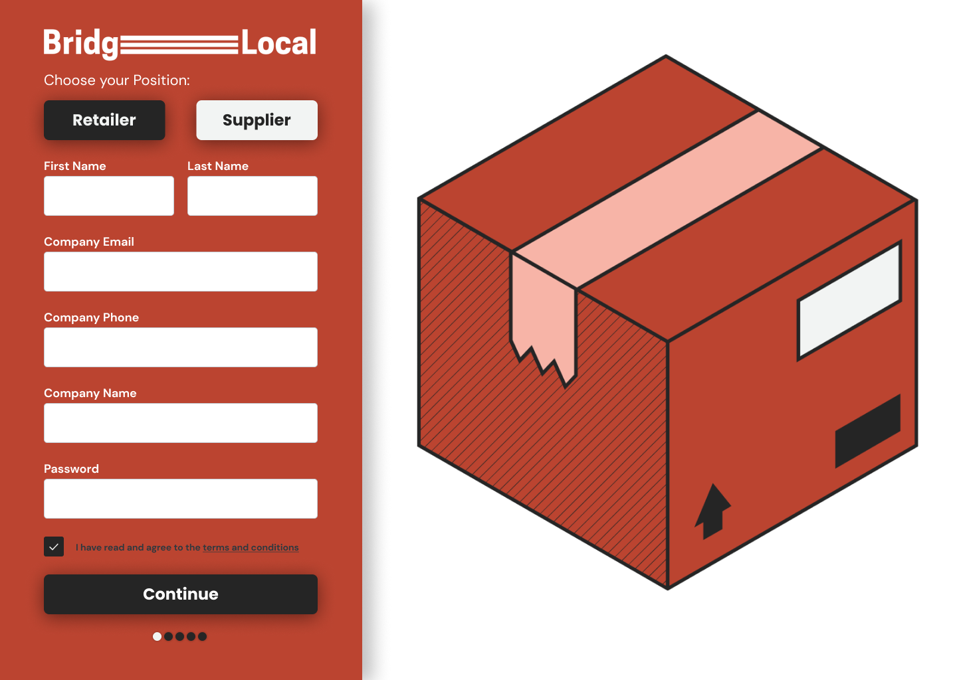

Figure 4.32 BridgeLocal – Supplier Sign up Page (1)

The figure 4.33 below shows the Supplier Dedicated Sign up page (2).

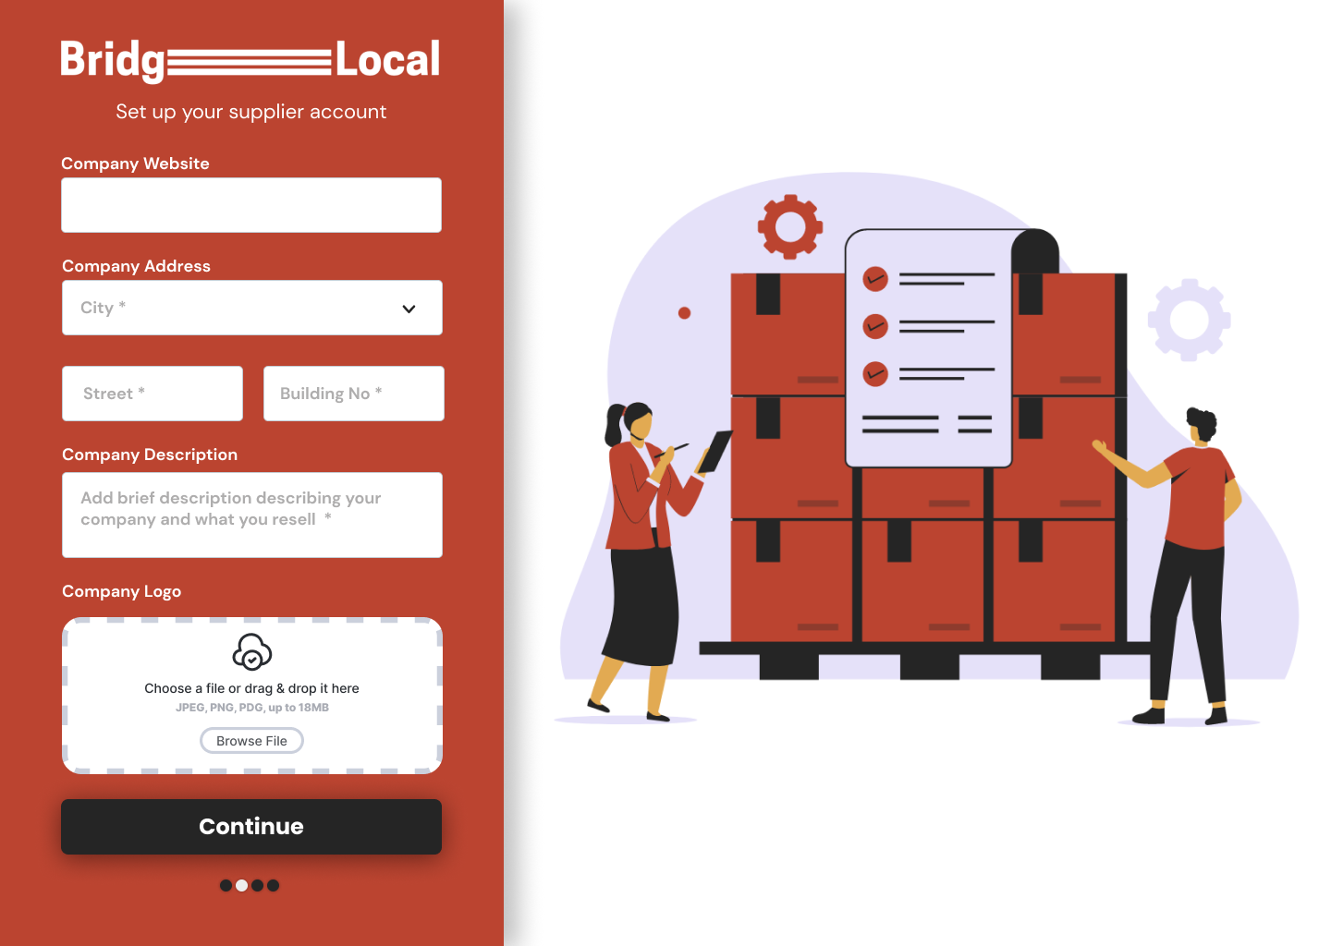

Figure 4.33 BridgeLocal – Supplier Sign up Page (2)

The figure 4.34 below shows the Retailer Dedicated Sign up page (3).



Figure 4.34 BridgeLocal – Supplier Sign up Page (3)

The figure 4.35 below shows the Administrator Dedicated Sign up page.

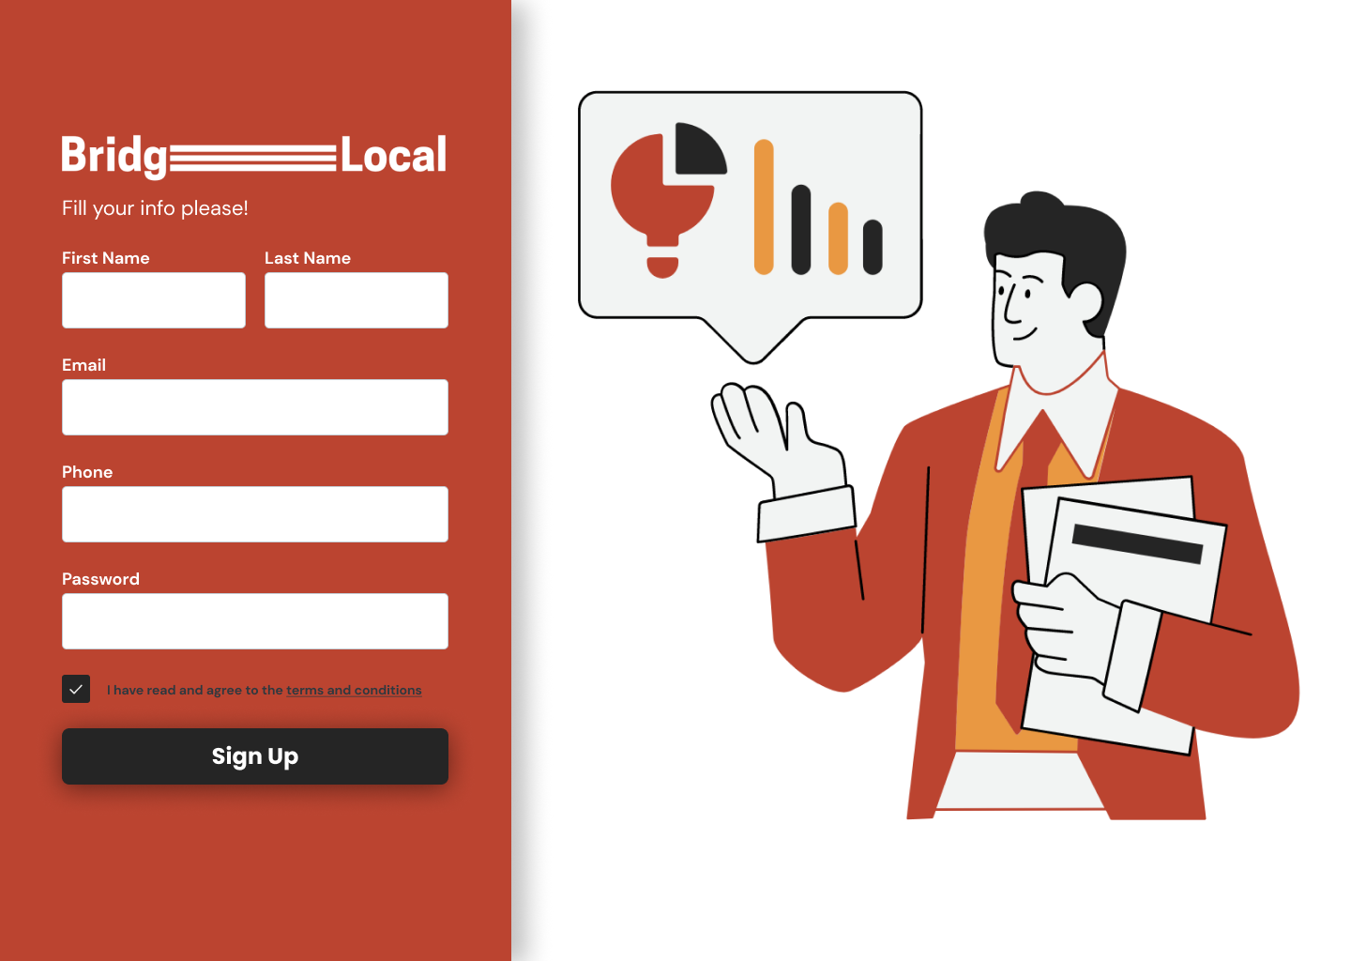

Figure 4.35 BridgeLocal – Administrator Sign up Page

The figures 4.36 and 4.37 below shows the User Management Administrator Pages.

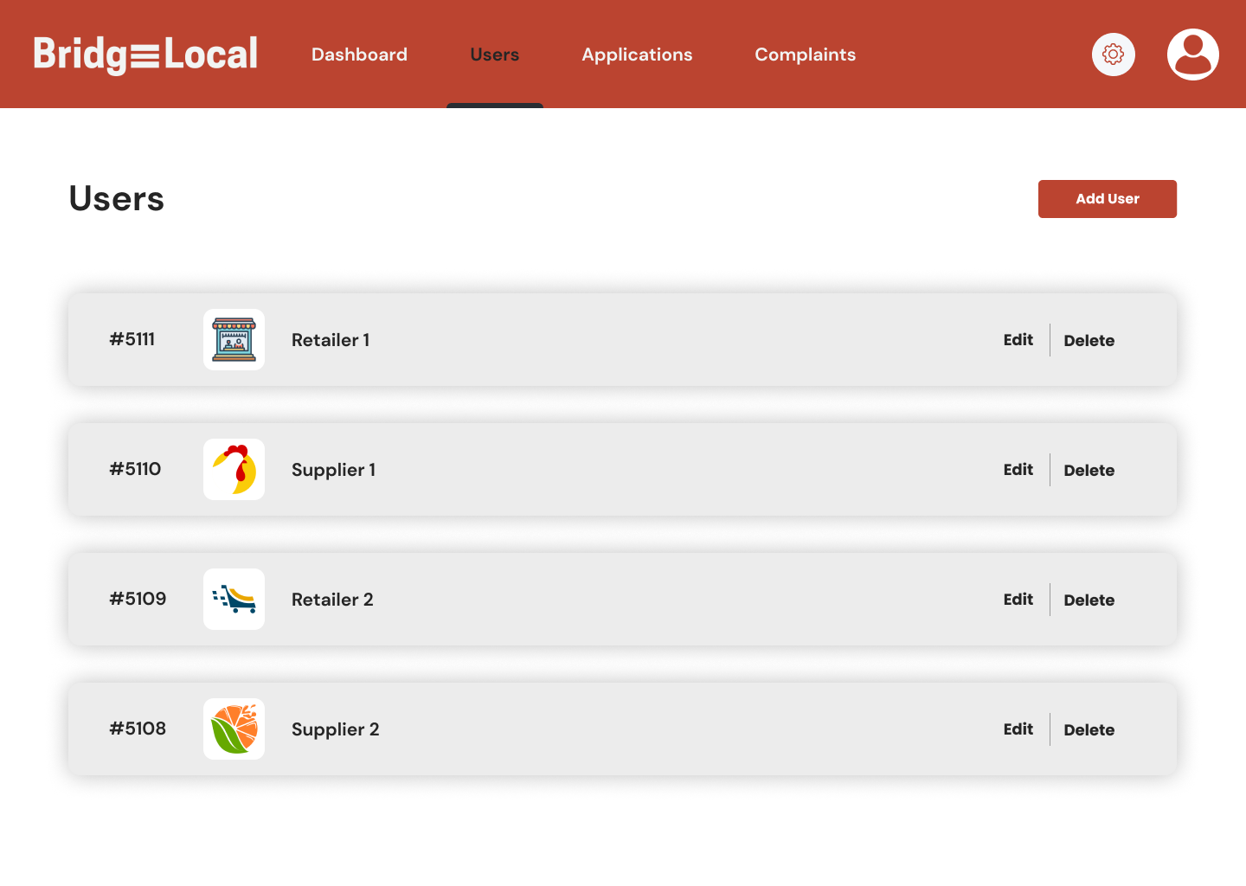

Figure 4.36 BridgeLocal – Administrator User Management Page (1)

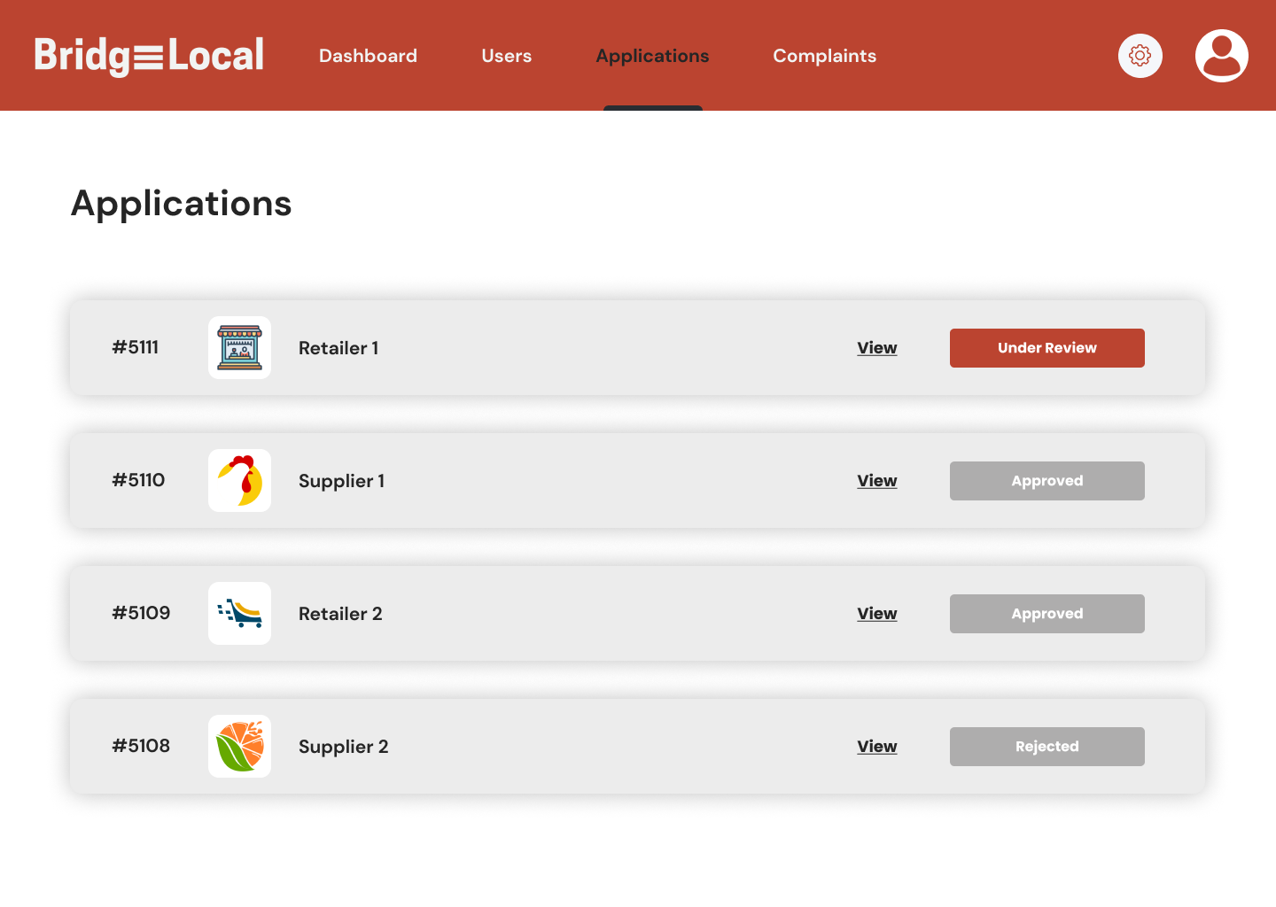

Figure 4.37 BridgeLocal – Administrator User Management Page (2)

The figure 4.38 below shows the Complaints Management Administrator Page.

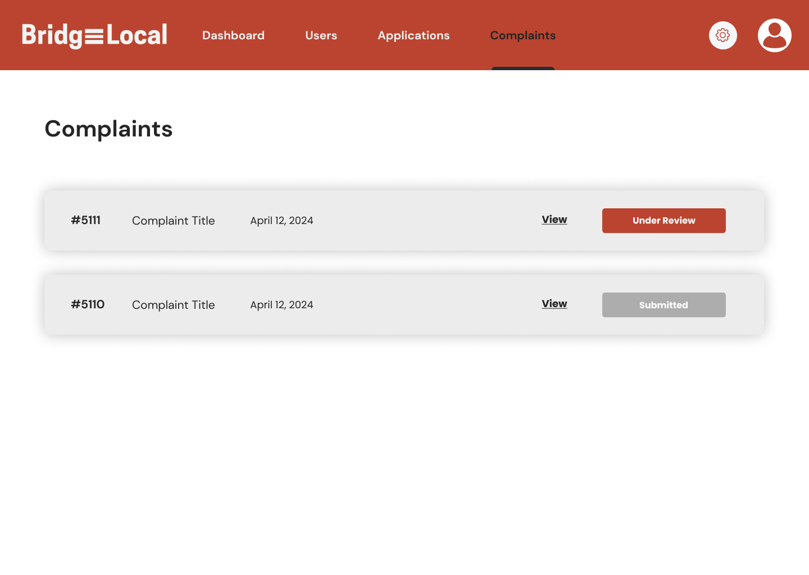

Figure 4.38 BridgeLocal – Complaints Management Page

The figure 4.39 below shows the Dashboard Administrator Page.

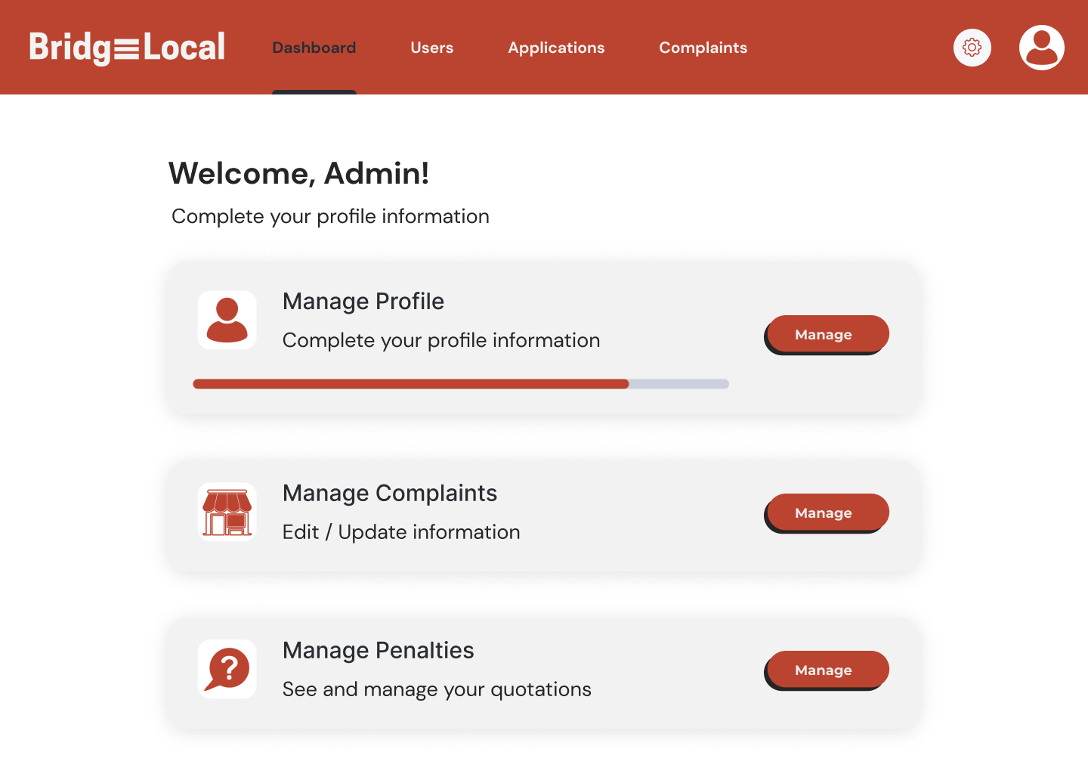

Figure 4.39 BridgeLocal – Administrator Dashboard Page

The figure 4.40 below shows the Marketplace Retailer Page (1).

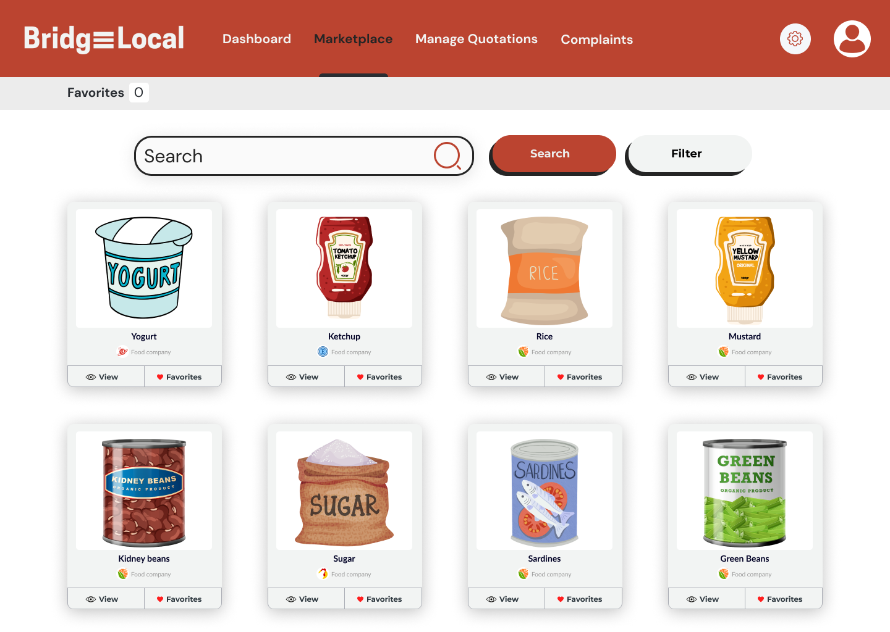

Figure 4.40 BridgeLocal – Marketplace Retailer View (1)

The figure 4.41 below shows the Marketplace Retailer Page (2).

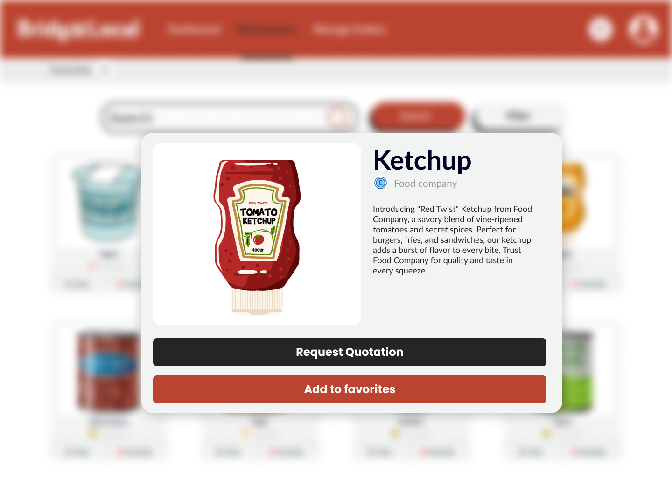

Figure 4.41 BridgeLocal – Marketplace Retailer View (2)

The figure 4.42 below shows the Retailer Related Page (1).

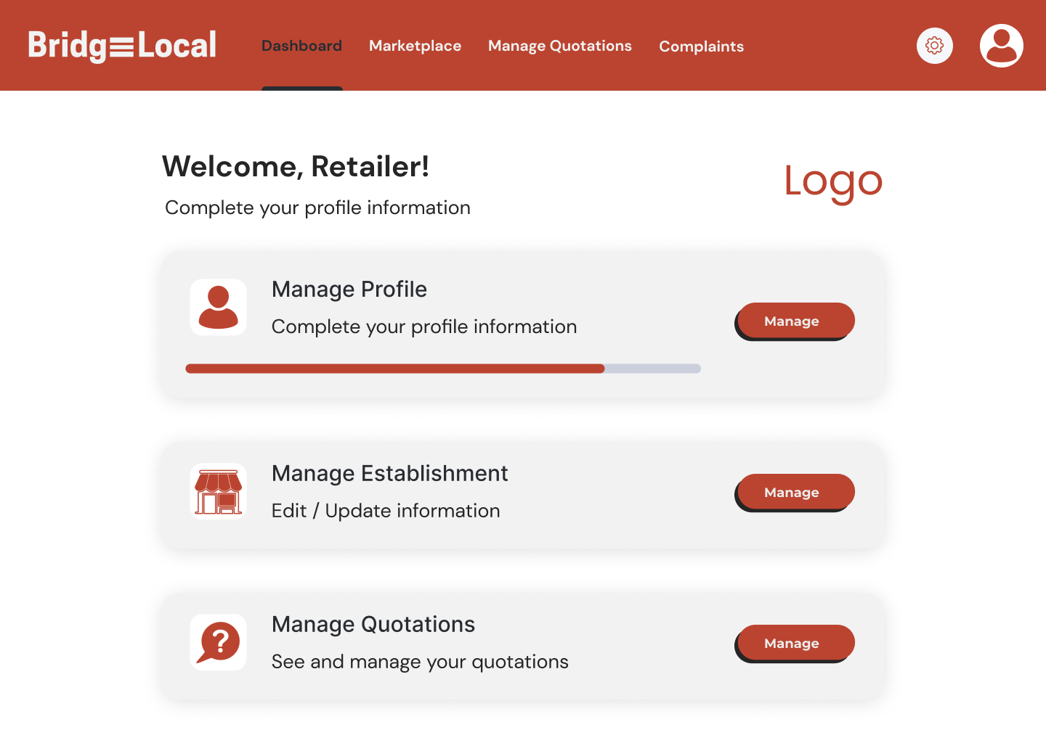

Figure 4.42 BridgeLocal – Retailer Related Page (1)

The figure 4.43 below shows the Retailer Related Page (2).

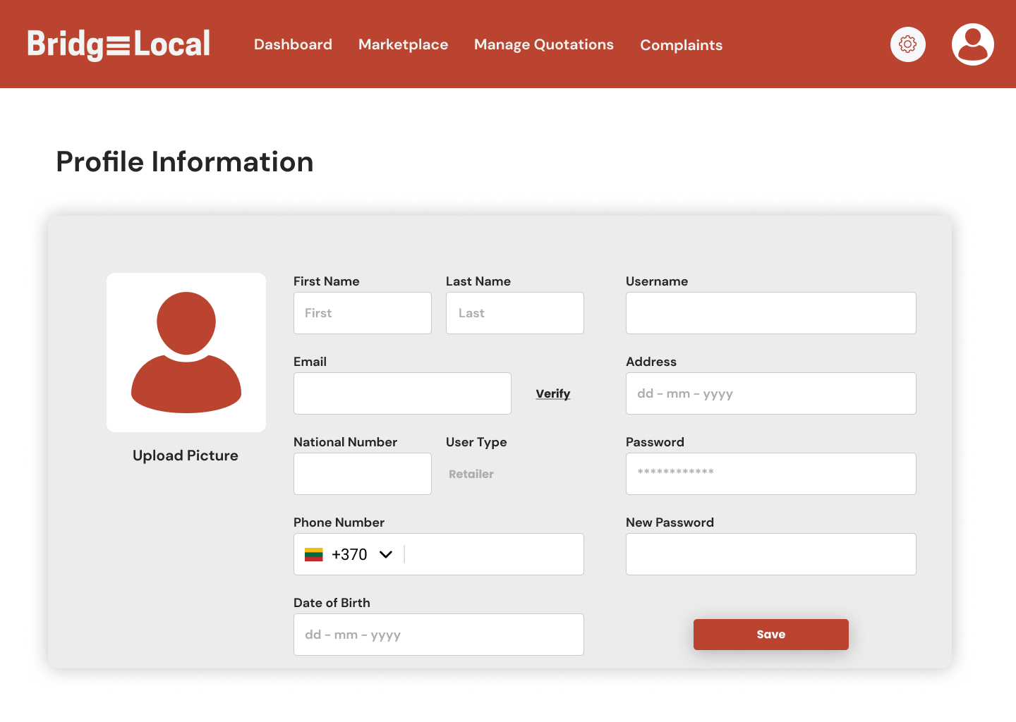

Figure 4.43 BridgeLocal – Retailer Related Page (2)

The figure 4.44 below shows the Retailer Related Page (3).

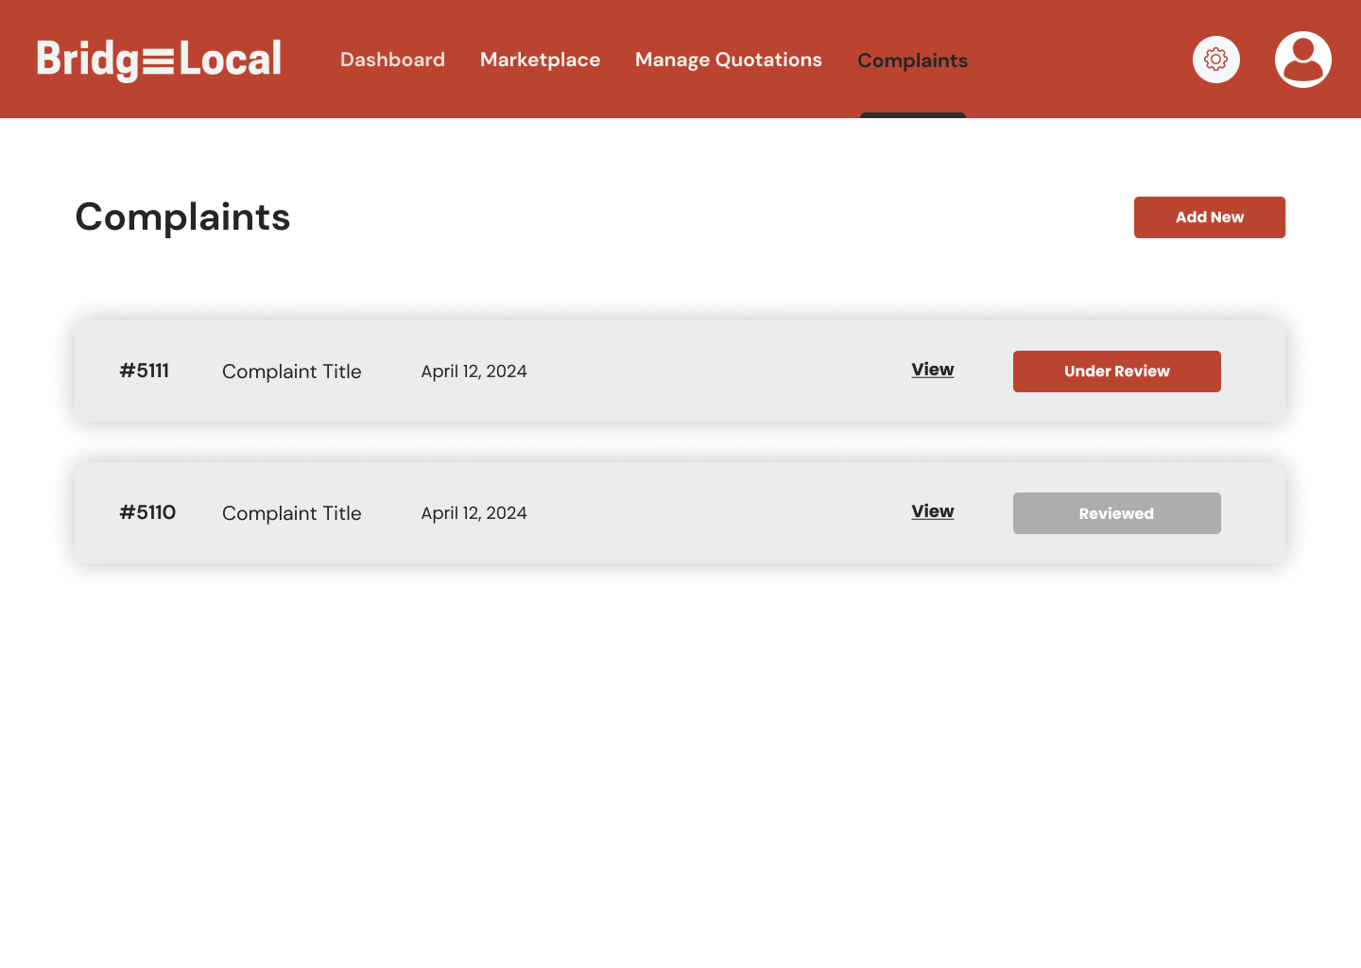

Figure 4.44 BridgeLocal – Retailer Related Page (3)

The figure 4.45 below shows the Retailer Related Page (4).

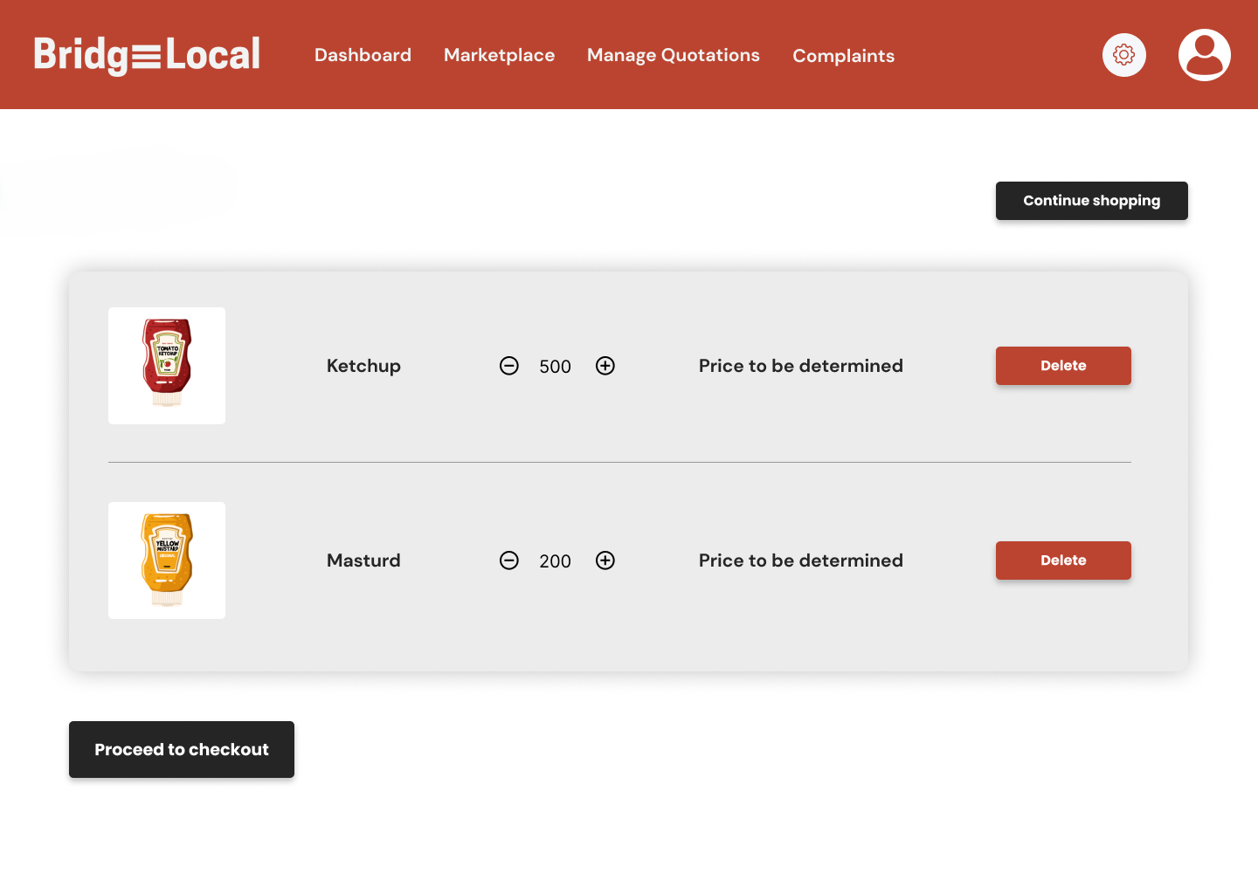

Figure 4.45 BridgeLocal – Retailer Related Page (4)

The figure 4.46 below shows the Retailer Related Page (5).

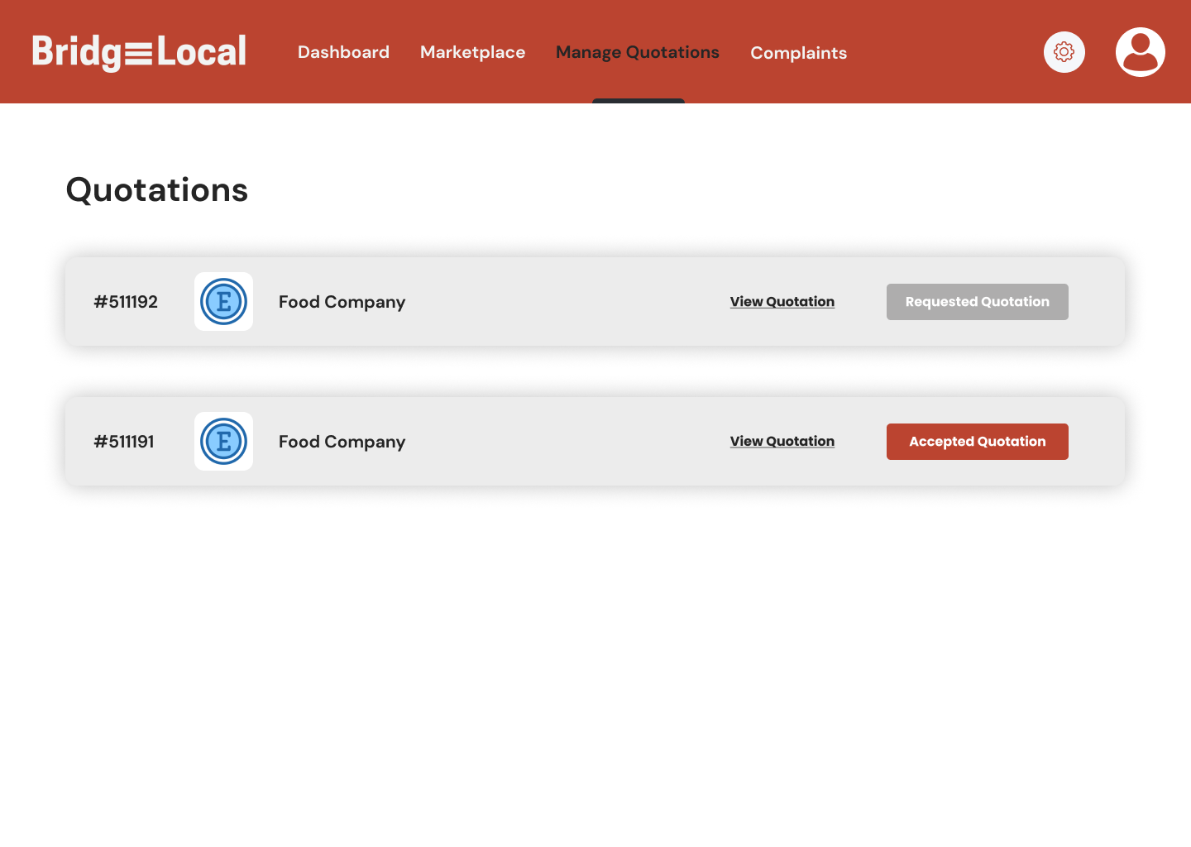

Figure 4.46 BridgeLocal – Retailer Related Page (5)

The figure 4.47 below shows the Supplier Related Page (1).

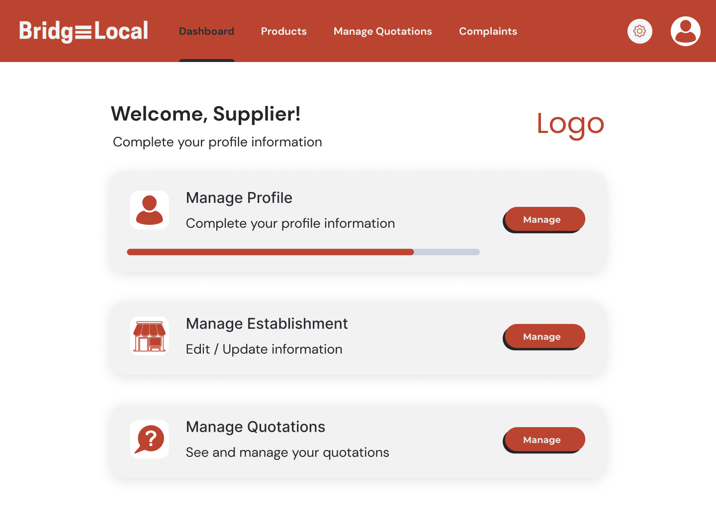

Figure 4.47 BridgeLocal – Supplier Related Page (1)

The figure 4.48 below shows the Supplier Related Page (2).

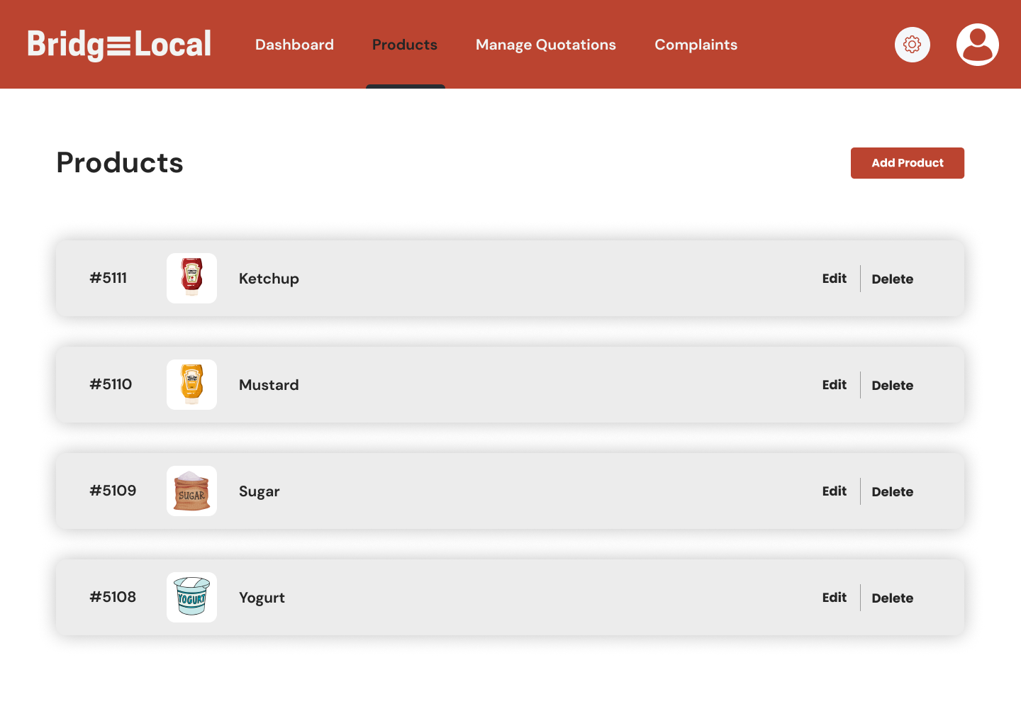

Figure 4.48 BridgeLocal – Supplier Related Page (2)

The figure 4.49 below shows the Supplier Related Page (3).

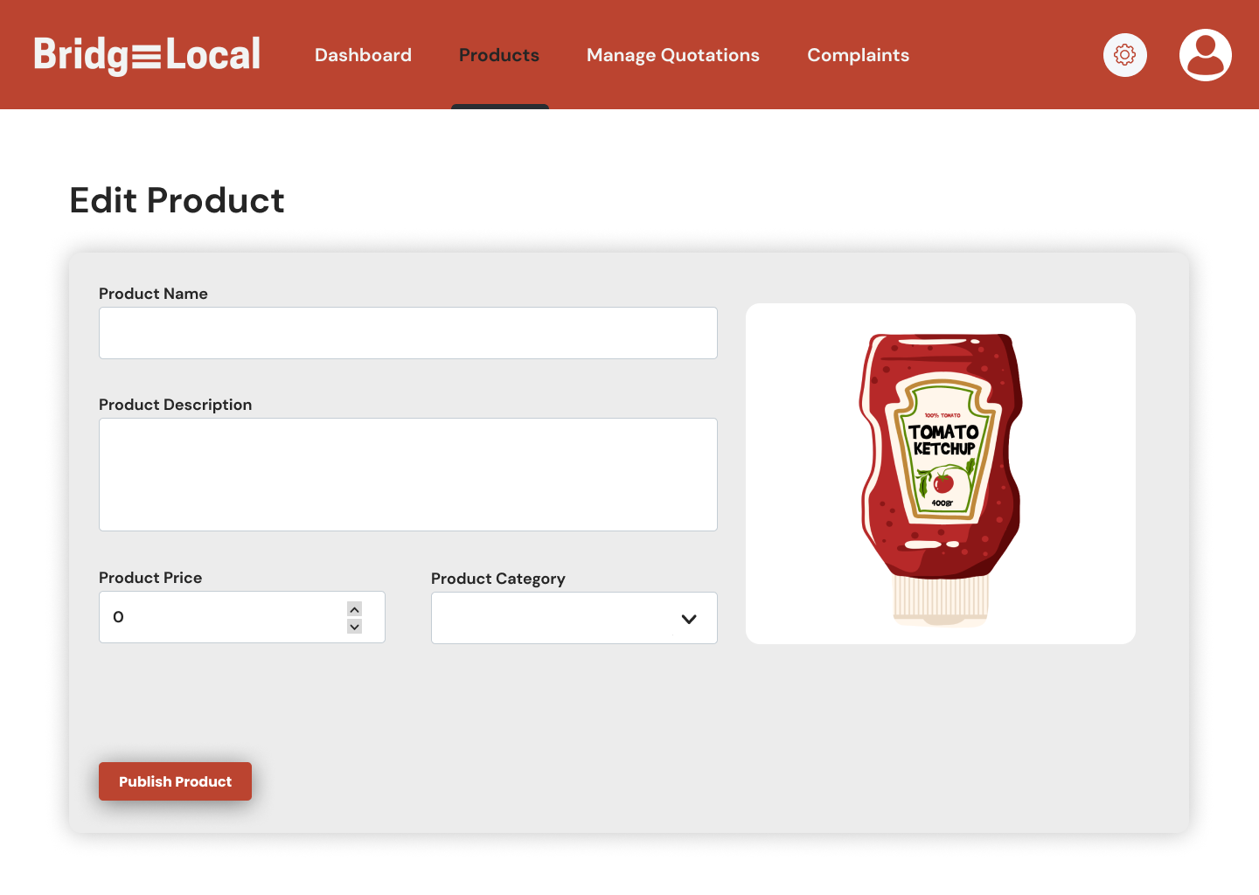

Figure 4.49 BridgeLocal – Supplier Related Page (3)

The figure 4.50 below shows the Supplier Related Page (4).

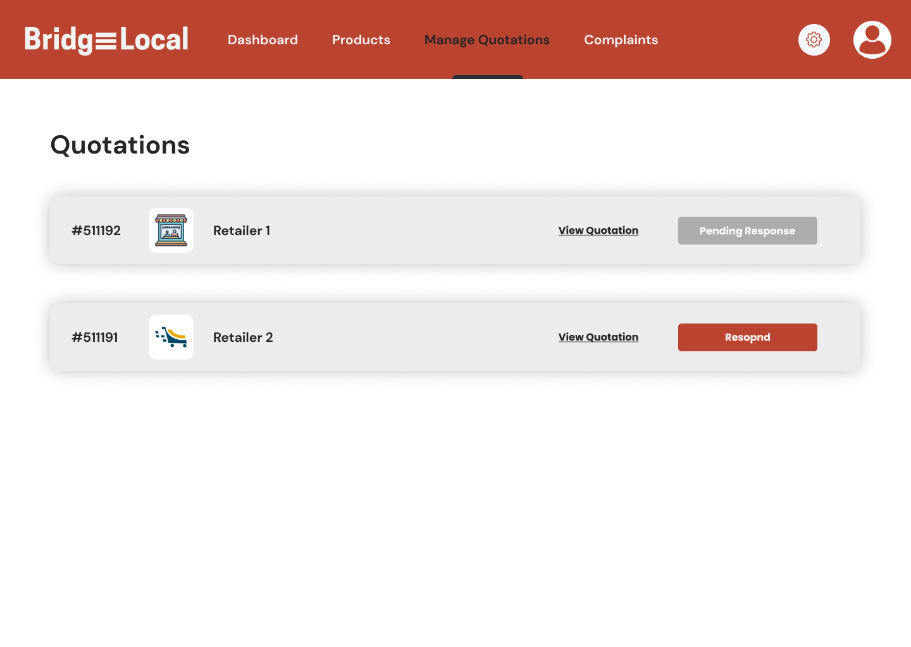

Figure 4.50 BridgeLocal – Supplier Related Page (4)

The figure 4.51 below shows the Supplier Related Page (5).

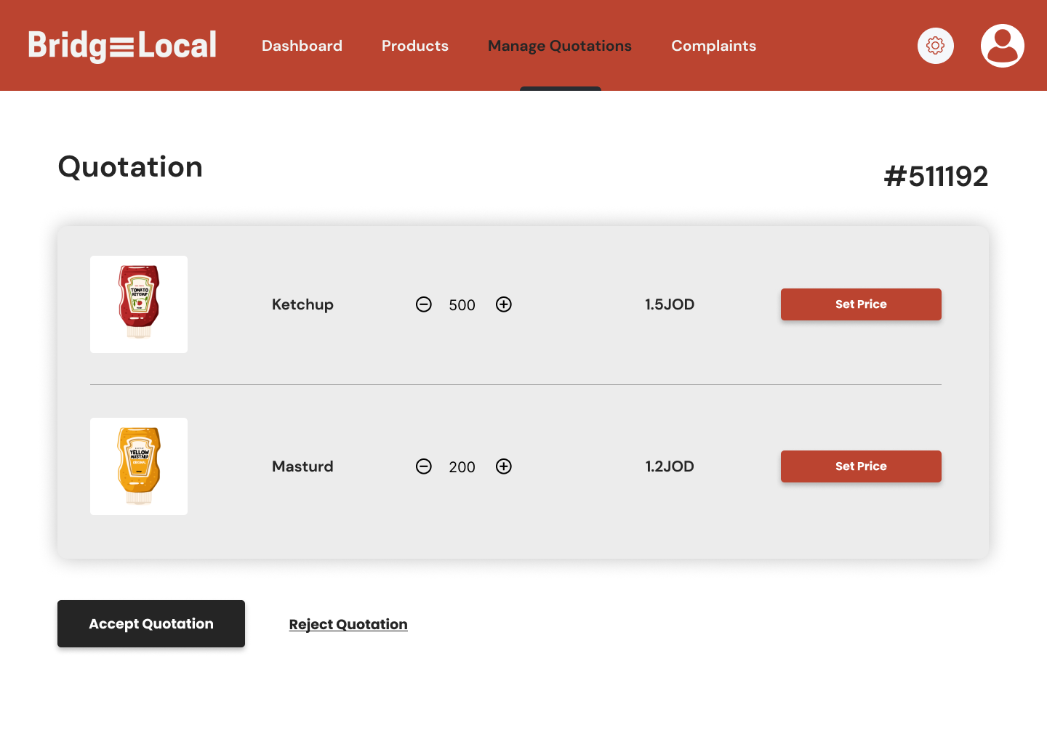

Figure 4.51 BridgeLocal – Supplier Related Page (5)

The figure 4.52 below shows the Supplier Related Page (6).

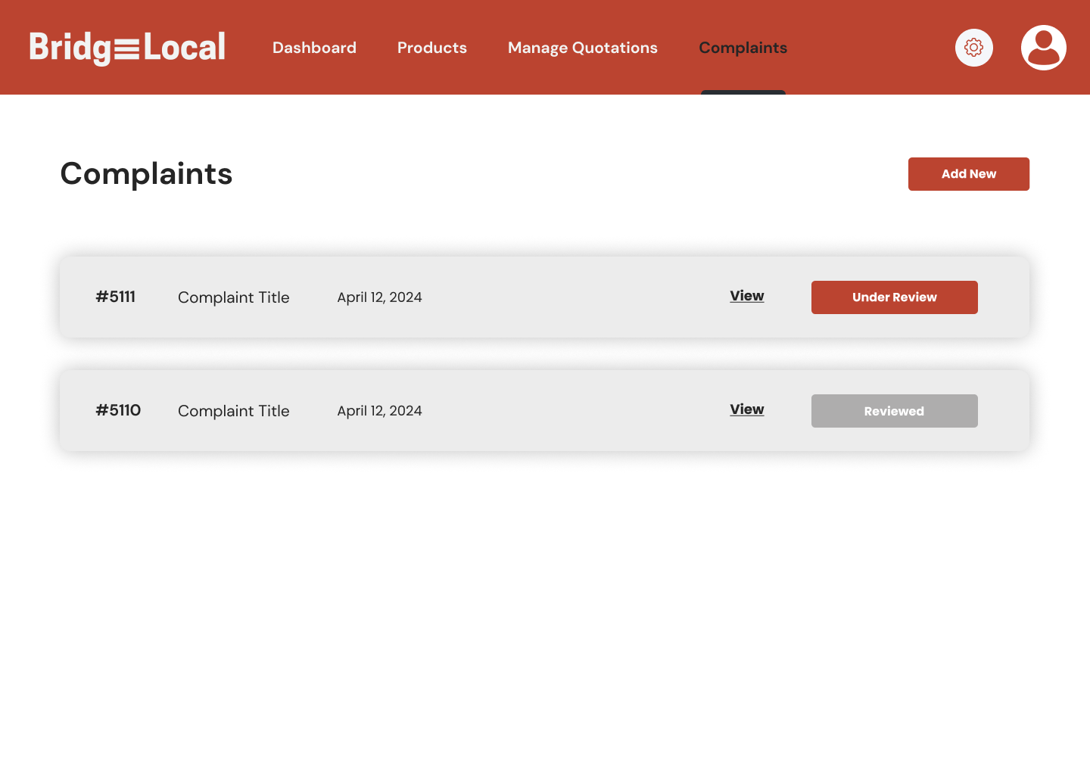

Figure 4.52 BridgeLocal – Supplier Related Page (6)

Full Prototype can be found using this link:

<https://www.figma.com/design/rp0D6geguhIh2vxRiAOzk5/BridgeLocal-UI?node-id=0%3A1&t=EplDQOmjK6LQhhzY-1>

# References

Humphreys, Paul, Ronan McIvor, and Trevor Cadden. "B2B commerce and its implications for the buyer‐supplier interface." Supply Chain Management: An International Journal 11.2 (2006): 131-139.

Hein, Andreas, et al. "Value co-creation practices in business-to-business platform ecosystems." Electronic Markets 29 (2019): 503-518.

Njiru, Nelly, Francis N. Wanyoike, and Isabelle Baltenweck. "Enhancing market access through business-to-business platforms: Key lessons and insights from northern Kenya." (2021).

RangeMe. "B2B commerce and its implications for the buyer-supplier interface." <https://www.rangeme.com/>

Faire. "Connecting Independent Brands with Retailers."

<https://www.faire.com/>

JungleWorks. "Providing Comprehensive Solutions for On-Demand Businesses." <https://jungleworks.com/>

# Appendix

To assess the viability of our project we conducted surveys targeting both suppliers and the general audience. The feedback from these surveys provided important insights into the challenges faced by local producers and the market demand for locally produced goods. Suppliers highlighted the need for better market access and visibility while the general audience expressed strong interest in supporting local products. These results confirm the potential impact of BridgeLocal in bridging the gap between local producers and retailers and enhancing market accessibility and fostering local economic growth.

## Local Supplier Results:

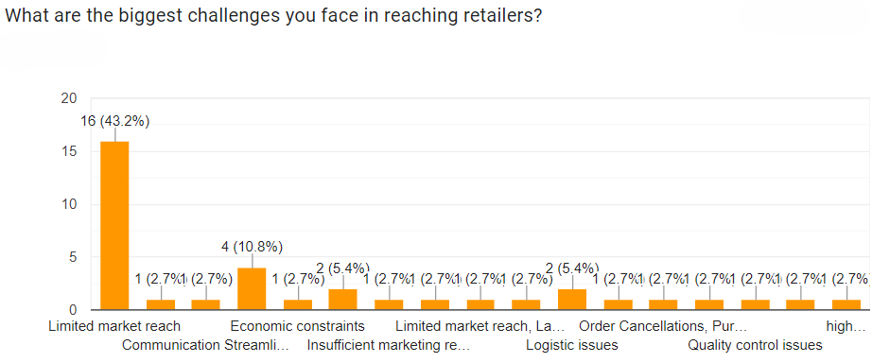

Figure A.1 Local Supplier Results

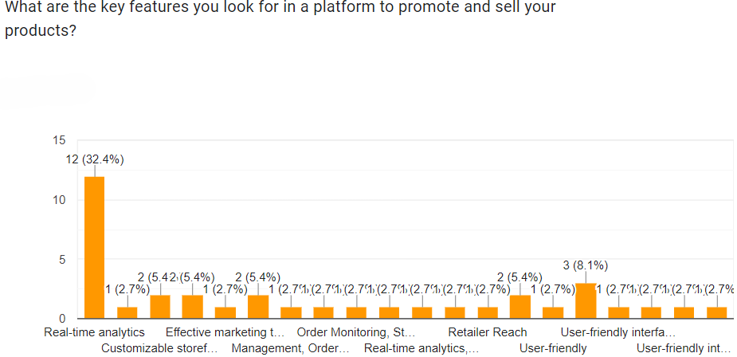

Figure A.2 Local Supplier Results

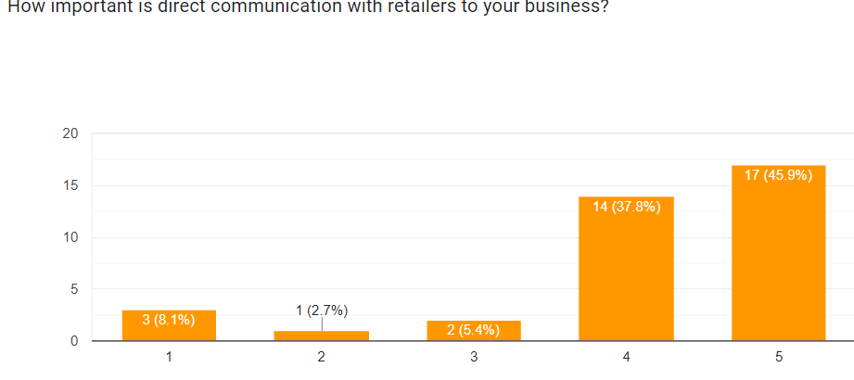

Figure A.3 Local Supplier Results

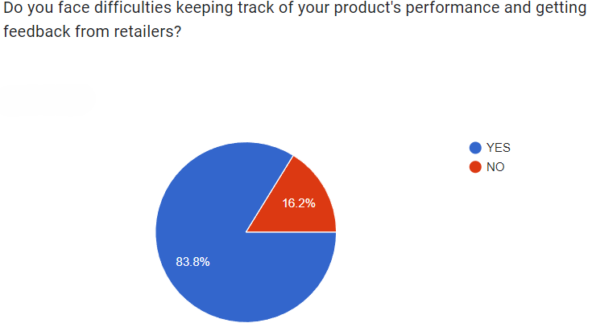

Figure A.4 Local Supplier Results

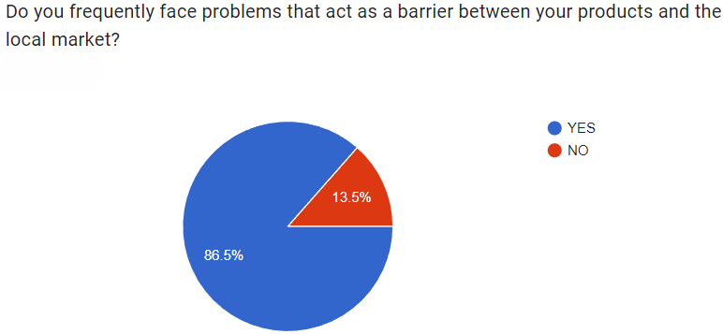

Figure A.5 Local Supplier Results

## General Audience Results:

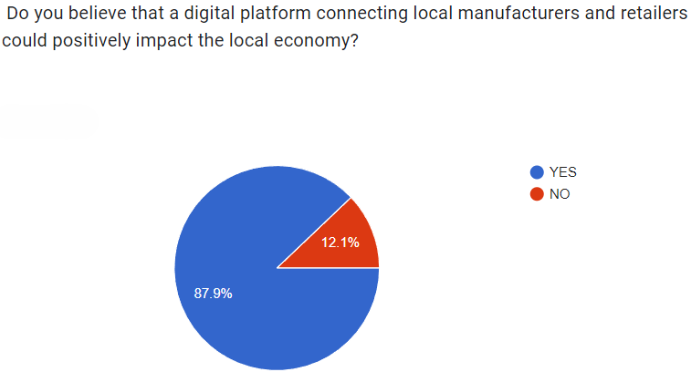

Figure A.6 General Audience Results

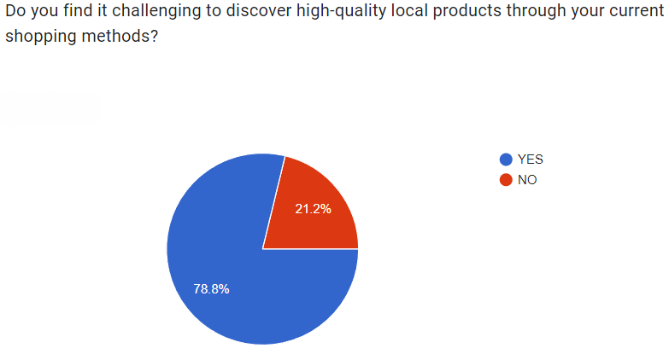

Figure A.7 General Audience Results